Definitions
Oligopoly - Few large producers, standardized or differentiated product, entry barriers, price makers, mutually interdependent.

Cartel - A group of firms formally agreeing to control the price and output of a product. (Formal collusion. Illegal in US (not abroad)

Game theory - the study of strategic interactions between rational decision-makers, used in microeconomics to analyze situations where outcomes depend on the choices of multiple parties, such as firms in an oligopoly

Nash Equilibrium -is equilibrium in which each player takes the best possible action given action of other players.

Collusion -a secret agreement between competing firms to manipulate the market for their own benefit, such as by fixing prices or limiting output, to act like a monopoly and increase profits

Tit-for-tat strategy- Under this Strategy in Repeated Games, a Player will do whatever other player did the last time.

Class Exersises
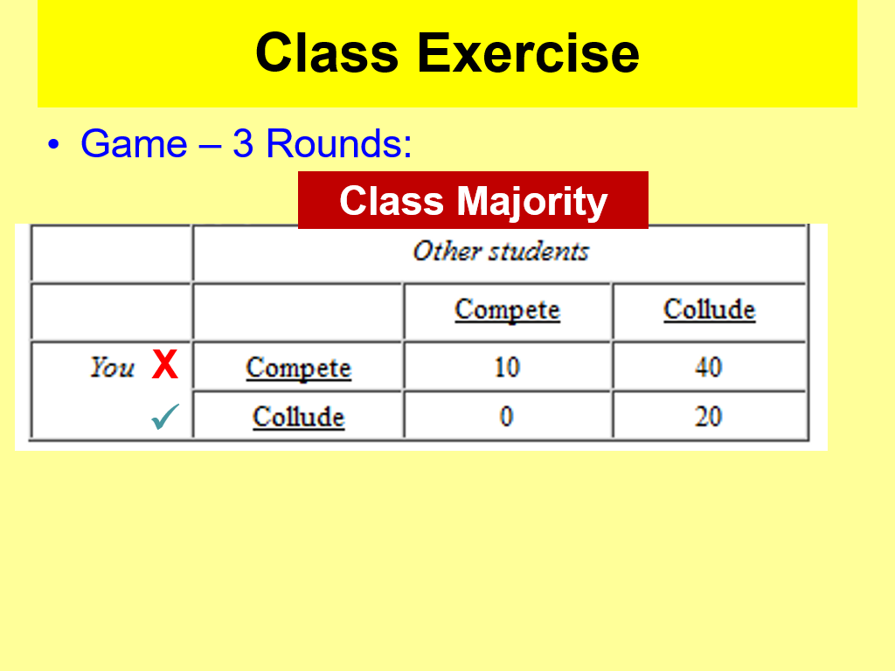
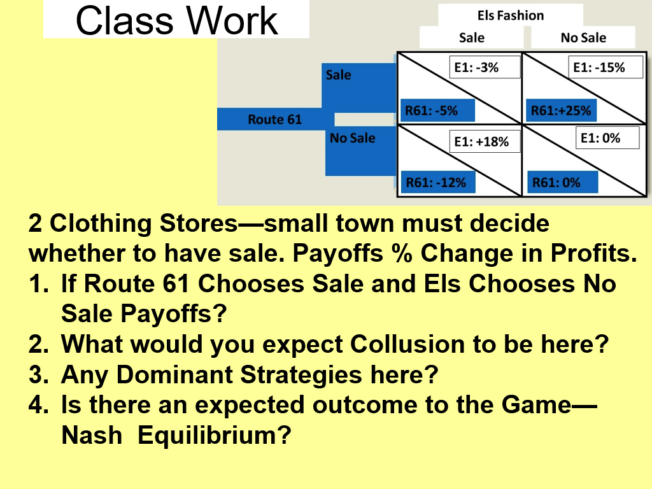

Notes
Opec is the Organization of the Petroleum Exporting Countries and operates as a cartel to influence oil prices and supply by coordinating member nations' production levels

The Prisoner's Dilemma is type of game theory model illustrating how two rational individuals may fail to cooperate, even if it serves their collective best interest

Many “games” are repeated indefinitely in the real world.

