Defintions
Marginal Revenue Product - The additional revenue generated as a result of utilizing 1 more unit of a variable resource. (2 Ways to Calculate: Total Revenue Method Or Marginal Product Method)

Marginal Resource Cost - the additional cost a firm incurs by hiring one more unit of a resource, such as labor

The Demand for Resources - the demand for resources is derived demand

Optimal Resource Utilization- when a firm produces at the point where the marginal revenue product (MRP) of a resource equals its marginal cost (MC), which in turn maximizes profit

Determinants of Demand- Examples for resource demand: 1. The demand for the good or service that the resource uses during production. 2. Overall productivity of the firm. 3. The price of another resource (Substitute/complement)

Derived Demand - A type of demand specific to resources that occurs as a result of the demand for the goods and services produced by those resources.
Substitute Resources - Resources that are viewed as replacements for one another.

Complements - Resources that are used with one another. EG: Hotdogs and ketchup

Class Exercise
Key provided on the following page
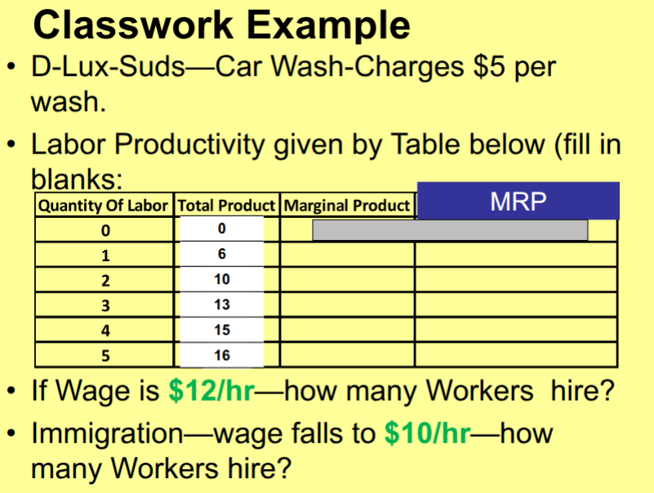
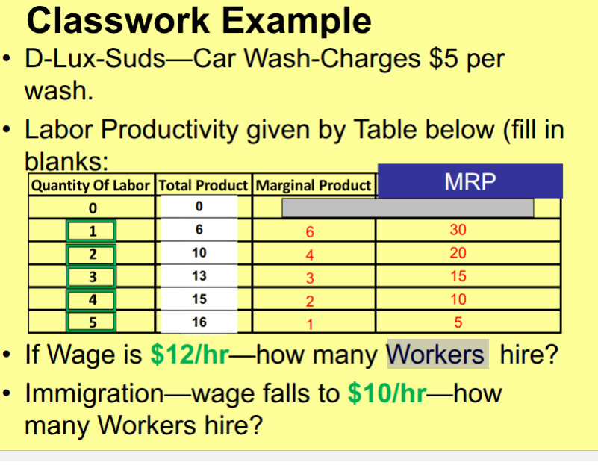

Notes
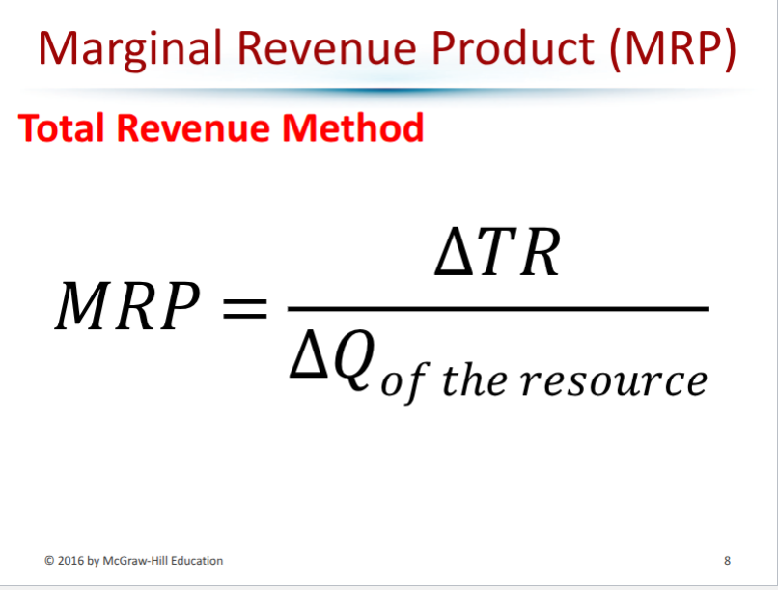

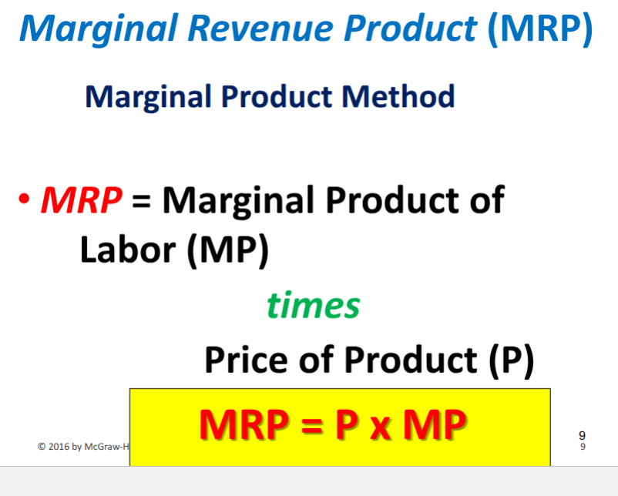

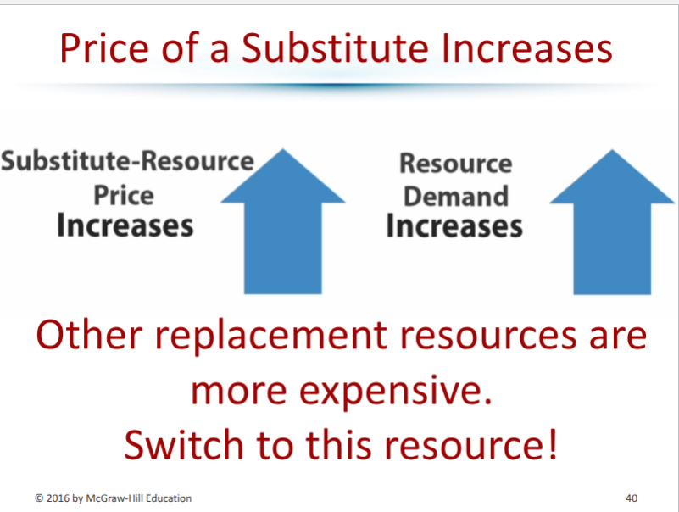
Remember!!! The opposite holds true for both of the following!

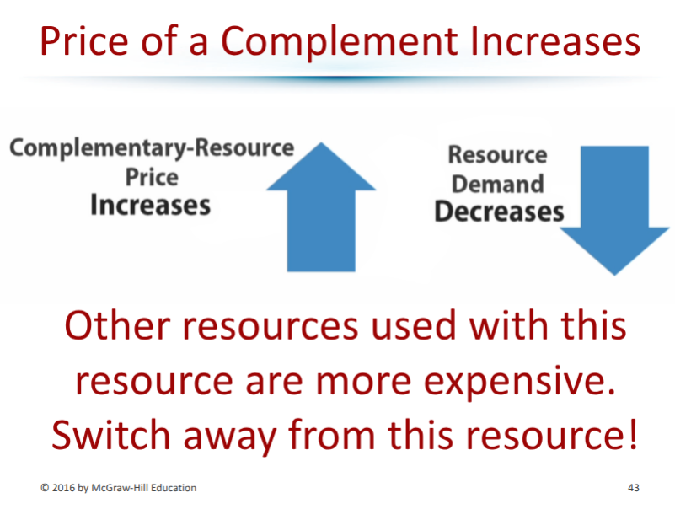
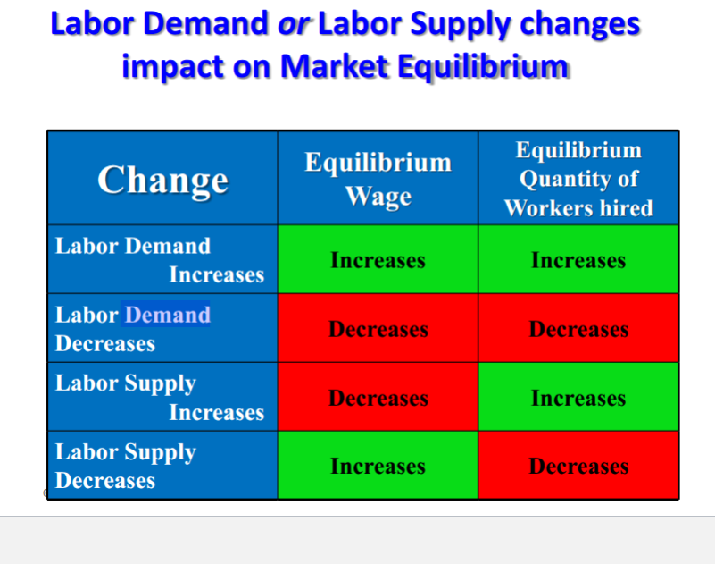
Factors that cause change in the labor supply: Demographic trends, immigration laws, education and training, unions and leisure time.

