Consumer Surplus: The difference between the maximum price consumers are willing and able to pay for a good or service and the price they actually pay.
Area below demand curve and above equilibrium price.
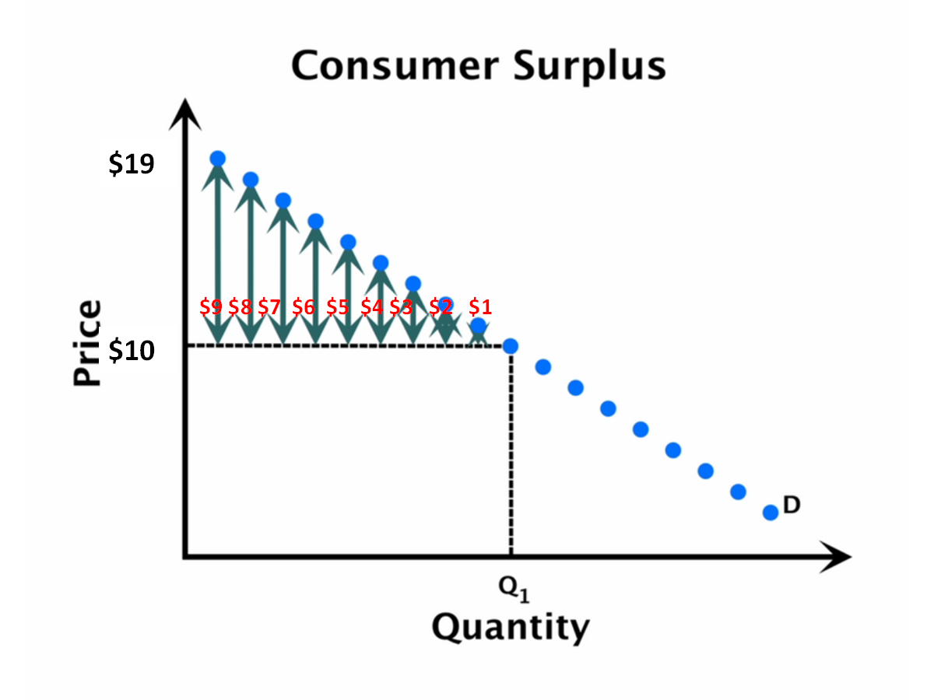
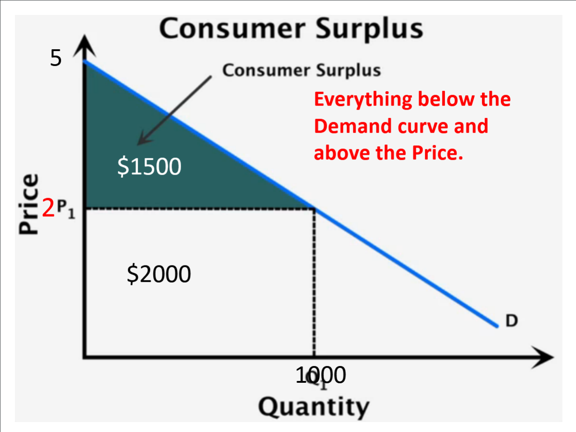

P₁

Producer Surplus: The difference between the price producers receive for a good or service and the minimum price they are willing and able to accept.
Area below the equilibrium price and above the supply curve.
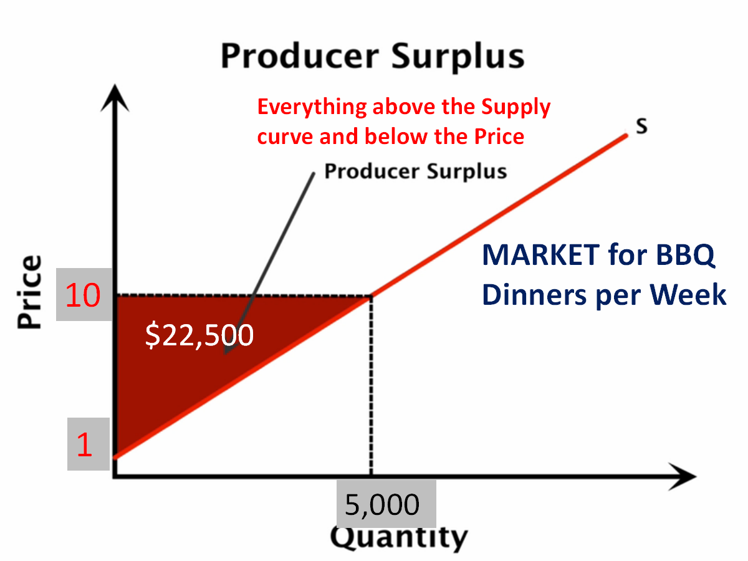

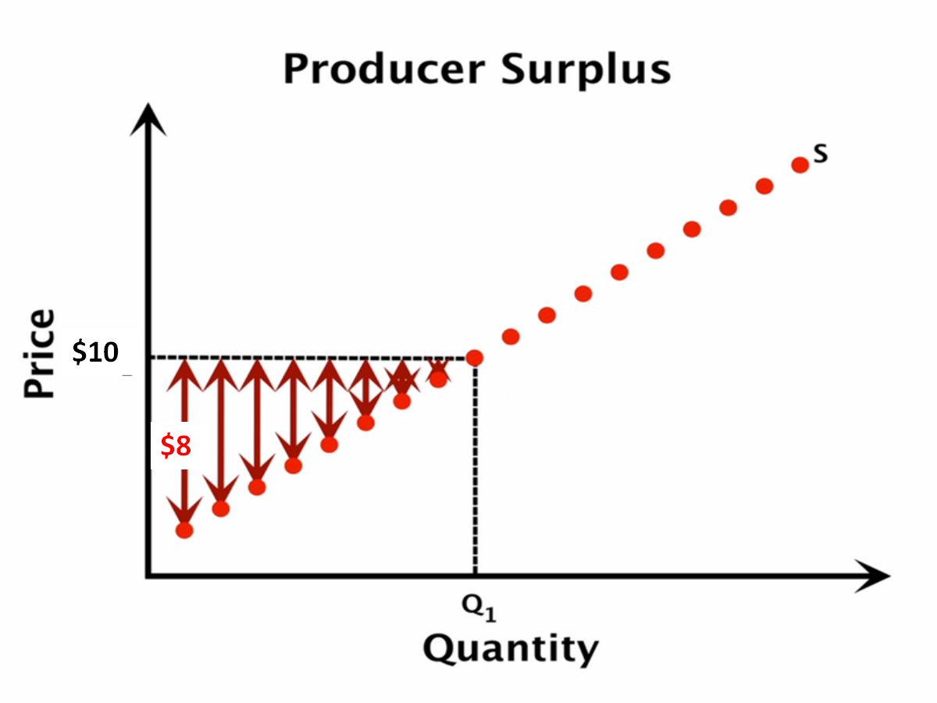

P₁

Q₁

Economic Surplus: The Sum of the Consumer and Producer Surplus.
_{(aka “The gains from trade”)}
Market clearing surplus: is when the market price is above its equilibrium

Market Efficiency: competitive markets are efficient when they maximize the sum of consumer and producer surplus. Total surplus - gains from trade ? (****** define for clarity******)

Deadweight loss: Missing surplus has a technical name in economics and it is called deadweight loss. (The tip of the deadweight loss triangle points towards efficiency. The wide base is at the inefficient quantity.)

Productive Efficiency: Producing output at the lowest possible average total cost of production.
Simply put: anywhere along the demand or supply curve.

Allocative Efficiency: producing the goods and services that are most wanted by consumers in such a way that their marginal benefit equals their marginal cost.
In simpler terms, its maximizing gains from trade. The point that is “most responsible”.

Price ceilings: (helps consumers) Legally established MAXIMUM PRICE a seller can charge. So needy people can pay lower prices than the previous equilibrium price.
Think of rent ceilings that are used to protect low income families.

Price floors: (helps producers) A legally established MINIMUM PRICE a seller can be paid. Think minimum wage law, and agricultural price supports!

