FINAL EXAM Review

In an Oligopoly, there are

barriers to entry and only one firm.
few firms and no barriers to entry.
many firms and no barriers to entry.
few firms and barriers to entry.

__________ means that each firm in an Oligopoly considers the reactions of its rivals when it determines its pricing policy.

Mutual Interdependence>>>>
No Barriers to Entry>>>>
The Large number of small firms>>>>
The Barriers to Entry>>>>

Firms in an industry reach an agreement to fix prices, divide up market share, or otherwise restrict competition….this is
Monopoly
Collusion
Competition
Regulation

When firms in an Oligopoly successfully collude, and they do not cheat on any collusive agreements, they are trying to achieve similar price, output and profits as...

The firms in regulated Industries
Monopolies
Firms in Monopolistic Competition
Perfectly Competitive firms

A Dominant strategy occurs when....

one strategy is best for a Player regardless of the rival's actions
the strategy that gives the one highest value in the payoff matrix
both players play the game repeatedly
one strategy is best for both Players combined payoffs

Use the Prisoner's Dilemma payoff matrix below for the following 4 Q s. It shows the payoffs (in terms of time in prison) for two criminals Blake and Reggie, who are in police custody trying to decide whether or not to confess. They would both like to spend as little time in jail as possible.
Prisoner’s dilemma:
- Players cannot communicate with each other
- If both confess to larger crime, each receives sentence of 5 years for both crimes
- If one confesses and the accomplice does not, the one who confesses will receive a 2-year sentence, while the accomplice receives a 15-year sentence
- If neither confesses, both receive a 4-year sentence

- Where would Collusion be?
- Either player dominant strategy?
- Nash Equilibrium (s)?
- Collusion maintained?
Reggie
Confess
Deny
Deny
5 Yrs
2 Yrs
4 Yrs

5 Yrs
15 Yrs
15 Yrs
2 Yrs
4 Yrs
Confess
Blake

Use the Payoff Matrix below for the Next 3 Q s

It describes a game of Chicken.
2 rebellious Teen drivers (Biff and Redd) face each other on a deserted stretch of highway, and start speeding towards each other. Each driver has 2 strategies>>Swerve or Don't Swerve. The Payoff matrix puts relative point values on the various outcomes (each driver would like to be the one that doesn't swerve while the other does).

By looking at the Payoff matrix, does either player have a Dominant strategy?
Chicken

Redd
Don’t Swerve
Swerve
-30
+20
-5
Swerve
-30
-10
-10
+20
-5
Don’t Swerve
Biff

Both Players have a Dominant strategy to "Swerve"
Both Players have a Dominant strategy to "Don't Swerve"
Neither Player has a Dominant Strategy in this game
Redd has Dominant Strategy "Swerve", Biff has Dominant Strategy "Don't Swerve"

Looking at the Payoff Matrix above, Mark all of the combinations below where there is a Nash Equilibrium in this game--if none mark that alternative.

No Nash Equilibrium in this game
Both Players "Swerve"
Both Players "Don't Swerve"
Biff "Don't Swerve" --Redd "Swerve"
Biff "Swerve" --Redd "Don't Swerve"

The Chicken game described above is supposed to represent...?

Price EG

- Where would Collusion be?
- Either firm dominant strategy?
- Nash Equilibrium (s)?
- Collusion maintained?

Universal Studios
High
Low
Disney World
High
Low
$110
$110
$150
$40
$150
$40
$97
$97

When Oligopoly games of Collusion are repeated and a "tit for tat" strategy is used,
the competitive outcome is more likely to be reached than when the game is played once.
because the game is repeated it is impossible to predict whether the competitive or the monopoly outcome is more likely.
the monopoly outcome is more likely to be reached than when the game is played once.
both firms begin to incur economic losses.

MARKET STRUCTURE COMPARISON

Market Structure Comparison

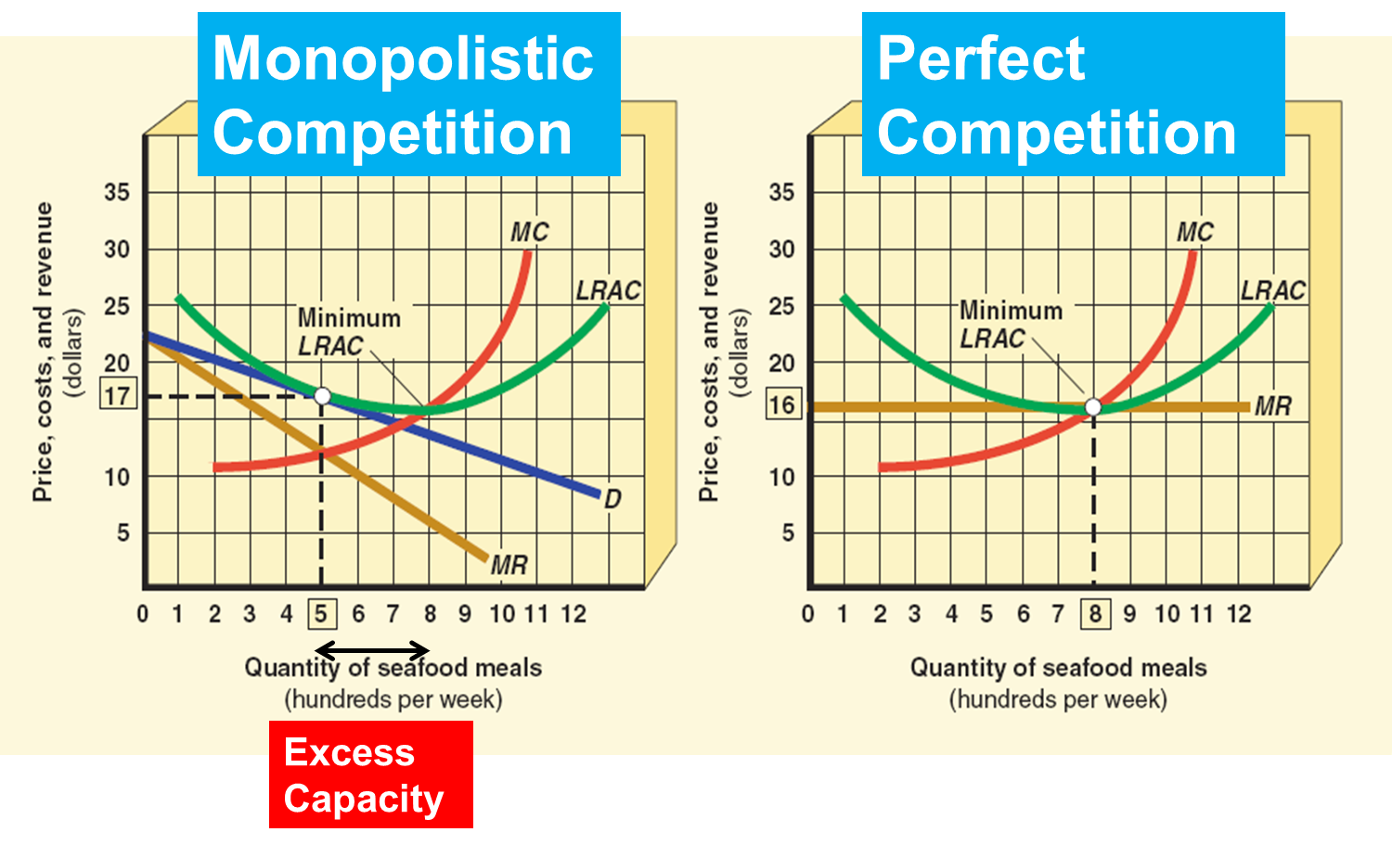

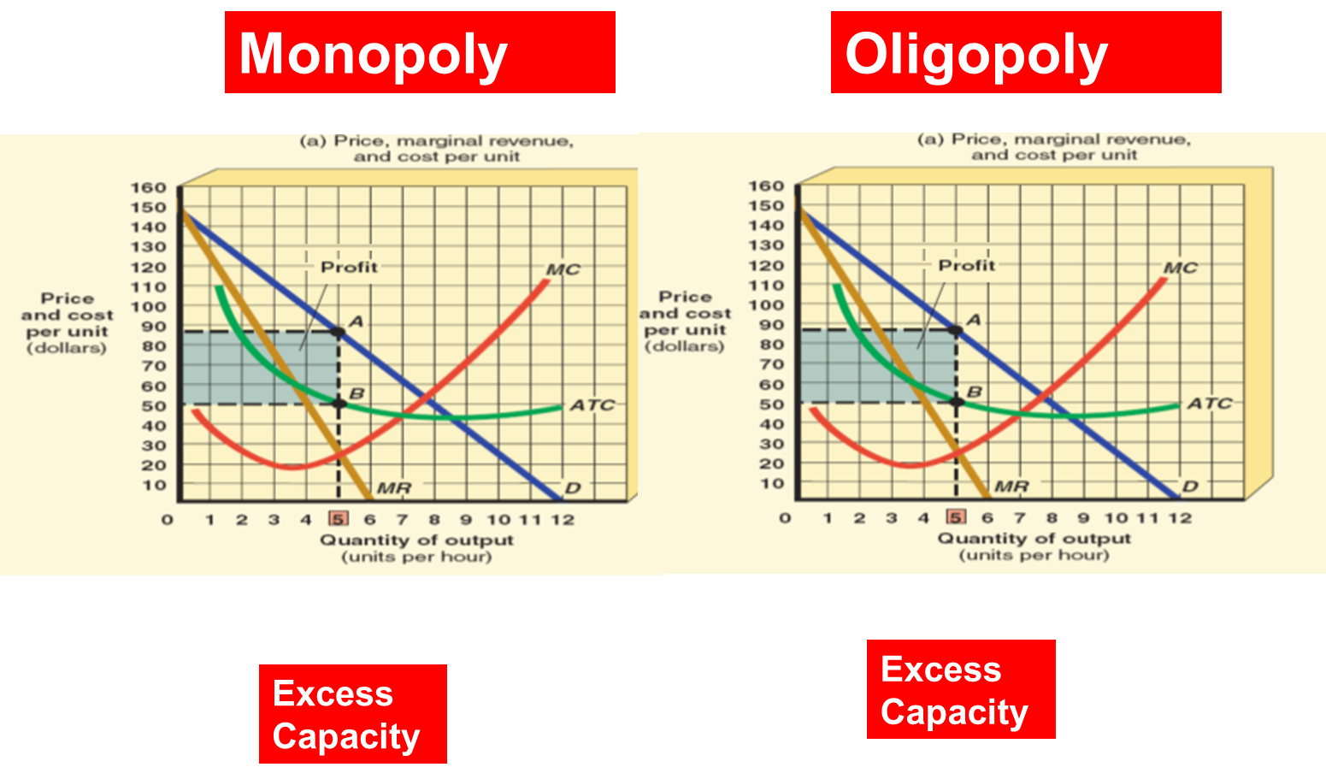
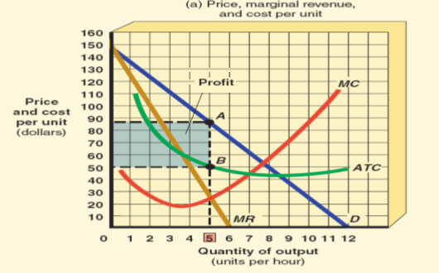
Monopoly
Oligopoly
Excess Capacity
Excess Capacity
Which Structures Cost Min in LR _____________ What is this called?__________
Which Structures Zero Profit in the LR?____
Which Structures Allocatively Efficient?

RESOURCES

The Marginal Revenue Product of Labor.....
The additional output produced as a result of utilizing 1 more unit of Labor (variable resource).
The additional revenue generated as a result of utilizing 1 more unit of Labor (variable resource).
The additional costs to the firm generated as a result of utilizing 1 more unit of Labor (variable resource).
The total costs of utilizing Labor (variable resource).

When deciding how much of any resource to use (like labor), firms maximize profit by hiring the resource until...
the marginal revenue product is greater than the marginal resource cost
the marginal revenue product equals the marginal revenue from hiring the worker
regardless of cost, because the firm cannot produce output without labor
the marginal revenue product equals the marginal resource cost

The table below shows a the Total Product schedule of ZaBest a producer of fine Pizza in a nearby college town. Assume they sell Pizza for $15 each. Fill in the blanks in the table below Calculating the Marginal Product of Labor, and then the Marginal Revenue Product (MRP) of Labor. No $ or units--whole numbers only.
Quantity of Labor | Total Product  (Pizza per day) | Marginal Product | Product Price | MRP
0 | 0 | ----- | ------- | ------
1 | 20 |  | 15
2 | 30 |  | 15
3 | 35 |  | 15
4 | 37 |  | 15
5 | 38 |  | 15

If the wage rate is $75 per day and based on the information you calculated in the table above, how many workers should ZaBest hire?

Based on the information you calculated in the table above, and if (after successful Pizzaworkers unionization) the wage rose to $130, how many workers should they hire now?

The Graph Below shows the Labor Market for Car wash workers in Ft. Worth.
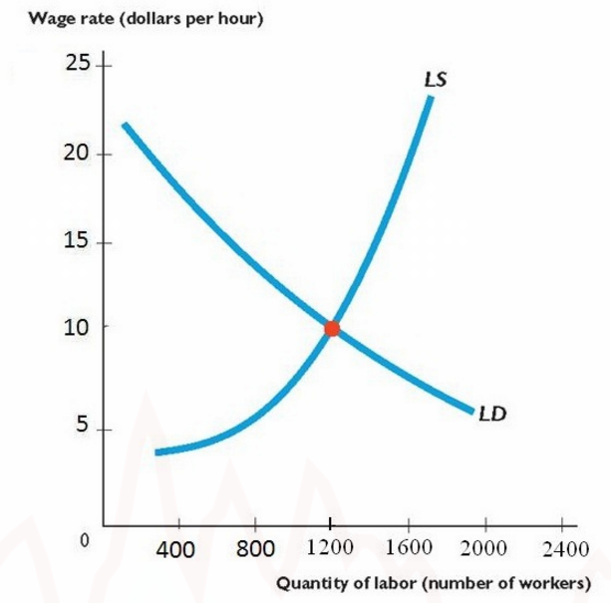

What would be the Equilibrium wage rate ?
What would be Equilibrium Quantity of Workers hired?

What Might shift the Labor Demand curve in the above example to the Left?
An Increase in the Market Price of Car Washes
An increase in Car Washer's preference for Leisure
A Decrease in the Market Price of Car Washes
An increase in the Productivity of the Car Washers

Use the Graph below for the Next 4 s. It shows the Supply and Demand curves for Labor in a Labor Market for Engineers.

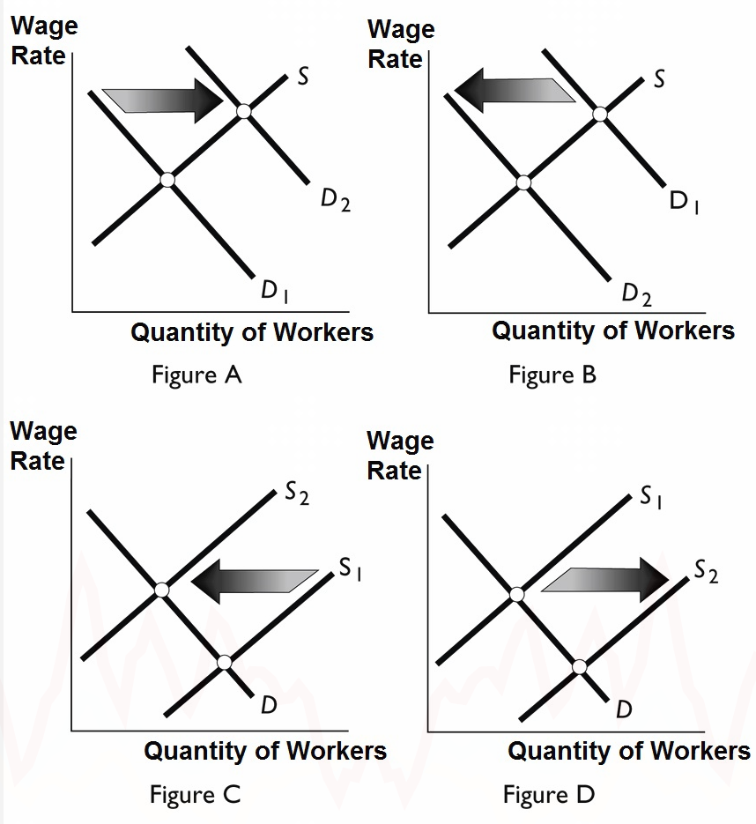

Which Graph above would show the impact on the Labor Market for Engineers of a Fall in the Price of Capital--if Capital and Labor are Complements?
A
B
C
D

Based on the Curve shift in the above graph which of the following will happen to the following?
The Wage rate _________
The Number of Workers hired ___________

Which Graph above would show the impact of a big new wave of Immigration?
A
B
C
D

Based on the Curve shift in the above graph which of the following will happen to the following?
The Wage rate _________
The Number of Workers hired ___________

MARKET FAILURE

___________ is a situation where a cost or a benefit is imposed on "third parties" who are not directly involved in the transaction or activity.

Products that have a negative externality (additional social cost--like _________) in an unregulated private market will be... _____________________
Products that have a positive externality (additional social benefit--like __________________) in an unregulated private market will be... _____________________

A chemical factory dumps waste into a river. The figure below shows the Demand curve for the chemical (D) and the Sp is the market supply curve and Ss is a supply curve comprising all costs of production, including external costs .
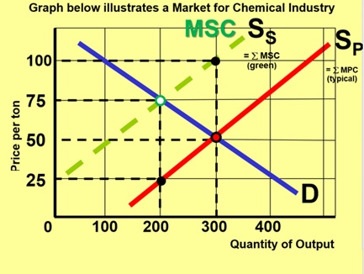
Just looking at the Demand and Supply curves you can tell…2 Supply curves –
>> external costs in the production of this product (from pollution).

What is the Private Market Equilibrium______________
What is the true Social Equilibrium_______________
Is there a Deadweight Loss society has to bear if it is at the Private Equilibrium as opposed to the Social Equilibrium?
Where_____

What can help Fix this?

Use the Graph Below for the following 3 Questions. It shows the annual Market for Flu Vaccines. Dp is the Private Demand Curve, Ds is the Social Demand Curve (based on Marginal Social Benefit—MSB)
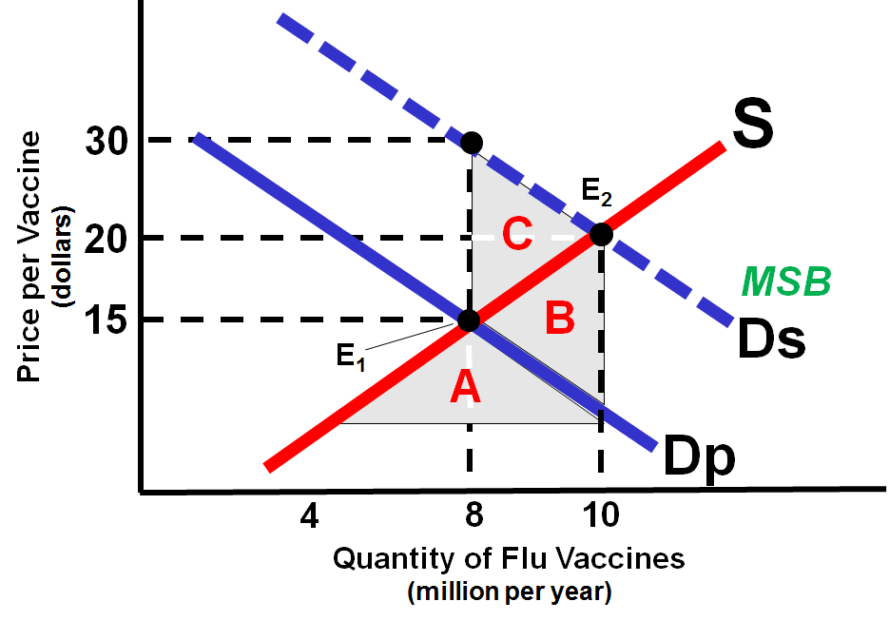
Just looking at the Demand and Supply curves you can tell…2 Demand curves –

What is the Private Market Equilibrium_______________
What is the true Social Equilibrium_________________
What Triangle represents the Deadweight Loss society has to bear if it is at the Private Equilibrium as opposed to the Social Equilibrium?

Government_____________can help Fix this

Lonestar Energy uses Coal to generate electricity. The Table below shows the Marginal Benefit of Annual Electricity Consumption, and the Private Marginal Cost of Annual Electricity Consumption. It is also known that use of Coal to generate electricity produces Sulphur Dioxide (which is a major cause of Acid Rain). The external cost of the Sulphur Dioxide is $150 per megawatt production of electricity. Use this for the next 3 s.
Based on the given information fill in the values for Marginal External Cost (MC External) and for Marginal Social Cost (MC Social).
Marginal Cost and Marginal Benefit
Quantity | MB Private | MC Private | MC External | MC Social
(millions of Megawatts)
1 | 300 | 50
2 | 275 | 75
3 | 250 | 100
4 | 225 | 125
5 | 200 | 150
6 | 175 | 175

What is the apparent, market, optimal amount of Electricity to produce every year?
_________________

What is the socially optimal amount of Electricity to produce if all the costs and benefits are considered?
____________________

What Do We mean by Rival_________
What Do we mean by Excludable ________________________
A Public good is ______________ and ___________________________
The Problem with Markets and Public goods is ____________

