Definitions
Monopolistic Competition- A market structure with many firms selling similar but differentiated products, such as restaurants or clothing stores. Availability of close substitutes, ensures that consumers can be more responsive to price changes.

Non-Price Competition- Rather than lowering prices a firm can compete by using: Reputation, location, advertising, packaging, product development, and better customer service.

Brand Loyalty- Customer dedication and “loyalty” to a product or firm.

Economic efficiency- is the absence of any deadweight loss, AND producing at the lowest possible ATC

Class excersises
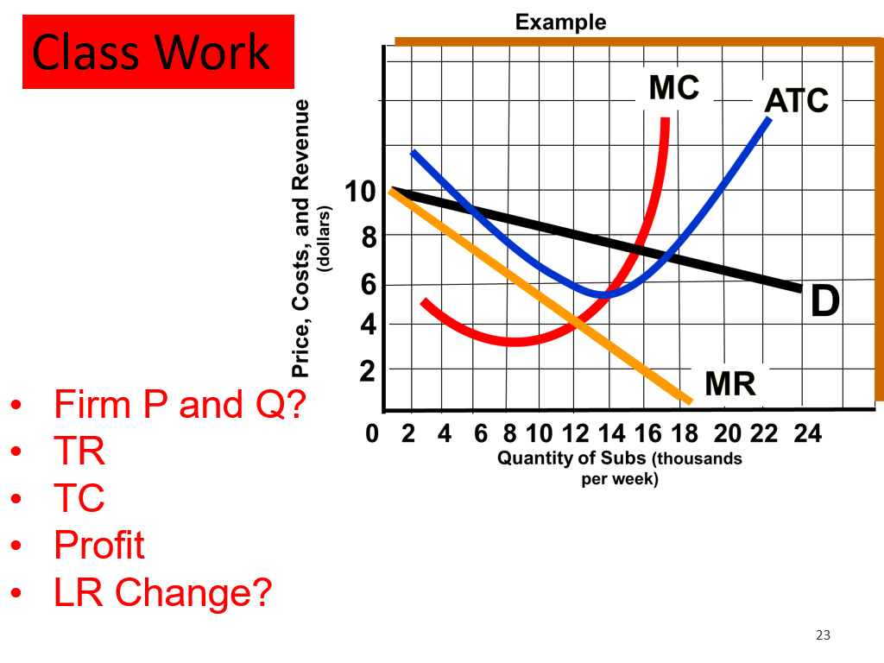
Key provided on page 2

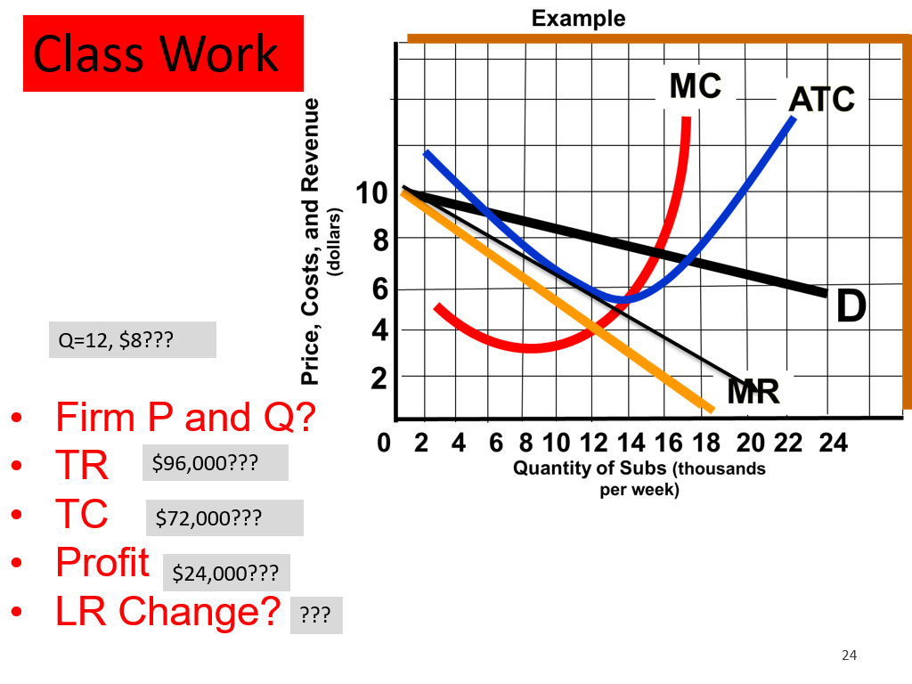

Notes
Monopolistic Competition ≠ Monopoly

Monopolistic Competition Characteristics: Relatively large number of sellers, Differentiated product, some control over price, relatively easy entry and exit.

Product differentiation creates real or perceived differences between goods and services. This enables firms to have some control over their price.

This allows monopolistic competitive firms to be price setters as opposed to price takers (perfect competition).

What is Non-Price Competition? Rather than lowering prices a firm competes by using: Reputation, Location, Advertising, Packaging, Product development, better service.

How does the demand curve for monopolistically competitive firms compare? It is less elastic (steeper) than a Perfectly Competitive firm, and more elastic (flatter) than a Monopolistic firm’s.

In Monopolistically Competitive markets, entry barriers are more prevalent than in Perfectly Competitive markets but less than it would be in Monopoly markets.

For monopolistic competition in the LR, we can assume it has relatively easy entry and exit. Thus, if one firm makes a profit in the SR, we can assume other firms will copy their market advantage, and erode it. So in the LR their demand curve will shift to the left. Until the point where they make Zero Profit.

Advertising can be utilized in order to generate brand loyalty. Which in turn convinces consumers to buy your product over the competitors. In doing so they can shift the demand curve to the right.

Remember, Productively efficient = Producing at the lowest possible ATC
And allocative efficiency is when a firm maximizes consumer and producer surplus. (aka producing where MB=MC)

What effect does advertising have on average costs in the LR?
It raises the Long-Run Average Cost curve.

Monopolistic competitions are not productively nor allocatively efficient. Consumers tend to prefer them, despite the higher prices, since they value choice.

