Definitions
Who is Adam Smith? (wrote the wealth of nations, key quote was “there must be competition for markets to function properly)

Monopoly Power- The ability of a monopoly to influence prices by controlling the quantities that it produces in the market. (Ex: Diamonds)

Barriers to entry- obstacles that make it difficult for new companies to enter a market, such as high startup costs, government regulations, patents, etc.

Economies of Scale- Economies of scale are the cost advantages that companies gain as they increase their output, leading to a lower cost per unit.

Pure Monopoly- Single seller, product has no close substitutes, price makers, barriers to entry

Natural Monopolies- Industry with Economies of scale, Long run average costs always decline as output rises. A single firm always lowers LRAC. EX: Public utilities.

Network good- Goods that increase in value to each user as a number of users increase. (So a firm with more users gets Economies of scale.

Economic Efficiency- the optimal use of resources to maximize output and social welfare

Productive Efficiency- Achieved using the fewest resources to produce a good or service. In a perfectly competitive market, competitive pressure pushes firms towards productive efficiency. (The same pressures do not exist in monopolistic markets!!)

Allocative Efficiency- Achieved when a firm produces where MB=MC. Pure monopolies stop short of allocative efficiency, in order to maximize their profits.

Price Discrimination- The practice of a seller charging different prices for the same product not justified by cost differences. ( Ex: night clubs ladies night, women get in cheaper whereas men are charged full price. Another example: Hospitals will charge patients 10x depending on health insurance and those without health insurance pay a fraction of the price.)

Unregulated Monopoly Price- The profit maximizing price that will result from an unregulated monopolistic market.

Regulated Normal Profit Price- A regulated price that is equal to the average total cost of production.

Normal profit- the minimum level of profit a company needs to stay in business, occurring when total revenue equals total costs, including both explicit and implicit (opportunity) costs.

Regulated Competitive Price- A regulated price that is equal to the Marginal Cost of production.

Relevant acts, that assist in regulating monopolies

Sherman act-1890- Anti-monopoly rules

FTC act- Federal Trade commision

Clayton act- 1914- anti-restraint of trade practices

Class Excersise
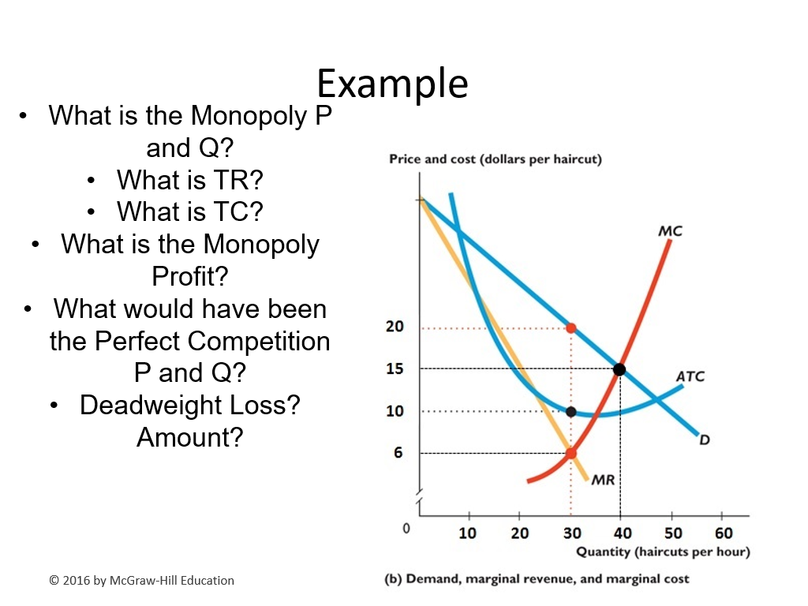
Answer key on the following page.

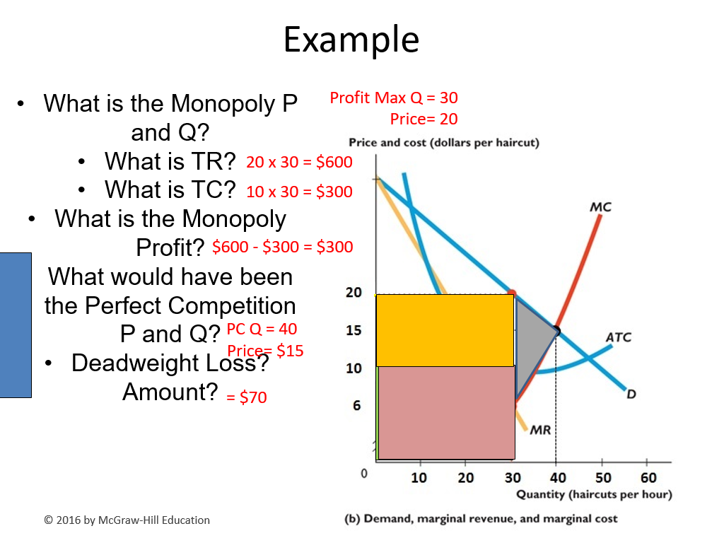

Notes
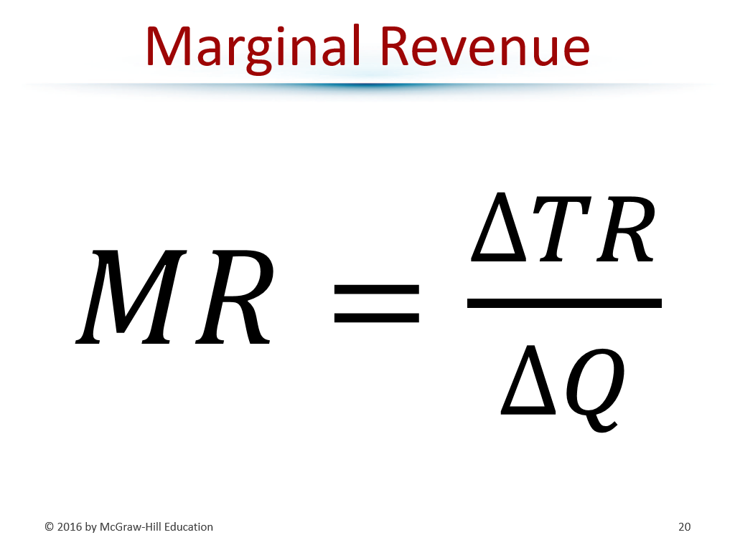

If a monopoly wants to increase its quantity, it must lower the price for every unit it sells.
On the flipside, they can reduce quantity in order to artificially increase their price. (think diamonds or limited edition yeezy’s.)

If a monopolist’s demand and cost curves give it a profit and nothing changes said curves, it can make a profit in the long run.

What is the case against monopolies? (IE, why are they a detriment to society?)
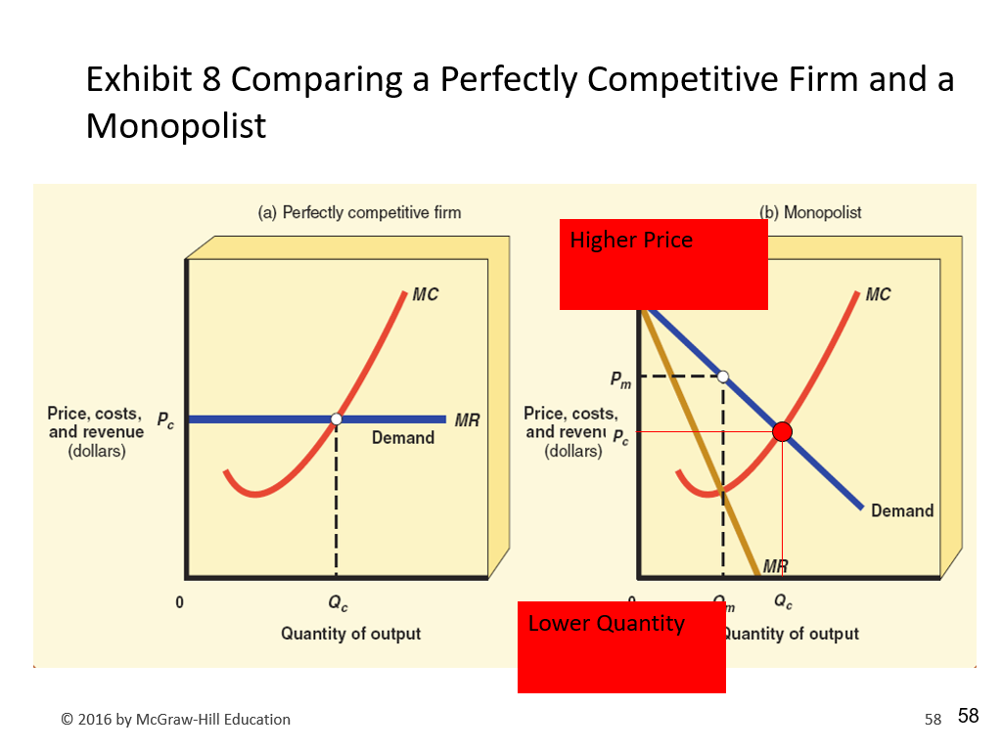
Higher prices, since they charge a price less than their marginal cost. Which leads to Deadweight loss. (inefficiency!) They do not practice cost minimization. (graph example provided below)

Is price discrimination unfair? Some consumers are charged higher prices, but at lower prices many buyers benefit by not being excluded from buying product if higher prices were charged for all. (Monopoly can gain more profits. As to be expected)

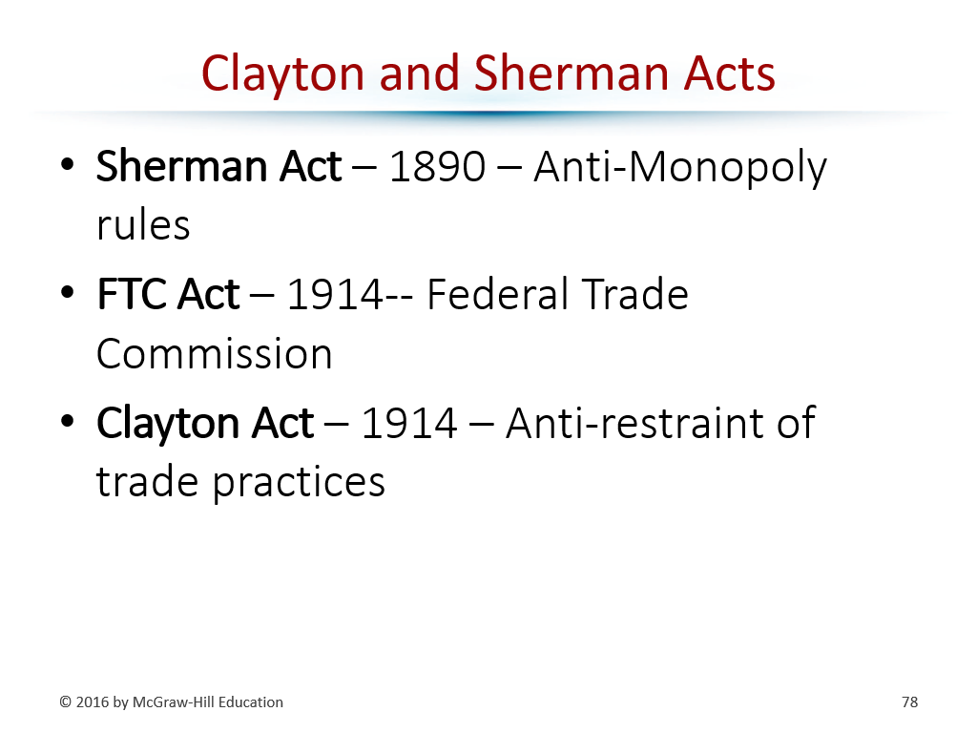

Important!!!

In perfect price discrimination monopolies, there is no deadweight loss. Since the monopolist charges each buyer their exact willingness to pay, making marginal revenue equal the demand curve and producing the efficient quantity where MC = demand. This eliminates deadweight loss by capturing all surplus without reducing output below the competitive level.

