Definitions
Perfect competition is characterized by a large number of sellers, a standardized product, price takes, and easy entry and exit to market.

Price takers - Firms that take or accept the market price and have no ability to influence said price.

Marginal Revenue - The change in a firm’s total revenue that results from a 1-unit change in output produced and sold.

Average Revenue - Revenue per unit sold, equal to total revenue divided by the quantity of output produced and sold.

Shutdown Point - The Price below which a firm will choose not to operate in the short-run.

Short-Run Supply Curve - A supply curve that represents SR relationships between Price and Quantity supplied.

Monopolistic Competition- a market structure with many firms selling similar but not identical products, creating a competitive environment that falls between a monopoly and perfect competition. (primarily focused on consumer/ brand loyalty)

Oligopoly - a state of limited competition, in which a market is shared by a small number of producers or sellers

Monopoly - the exclusive possession or control of the supply of or trade in a commodity or service

Normal profit -is the minimum profit needed to keep a firm in business long-run. It occurs where price = average total cost (ATC), covering all explicit and implicit costs but yielding no surplus beyond that.

Allocative Efficiency - MB=MC(producing what people want. Productive efficiency doesn't care about wants, it only cares about productive efficiency.)

Productive Efficiency - Achieved using the fewest resources to produce a good or service. (in perfectly competitive markets, competition pressures firms towards productive efficiency. In LR in Perfect Competition, produce at Quantity with Lowest ATC… so P = minimum ATC.

Class Excersise
Key provided on the following page

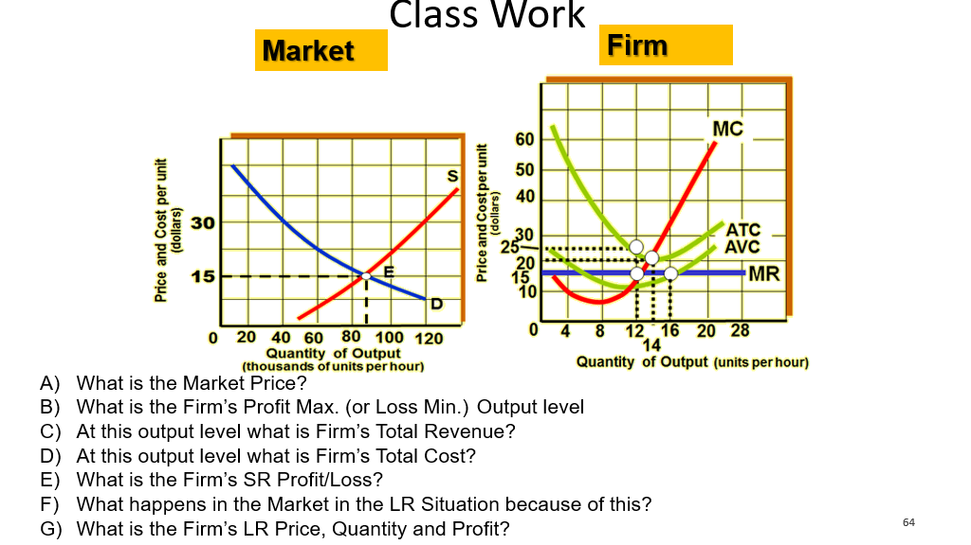

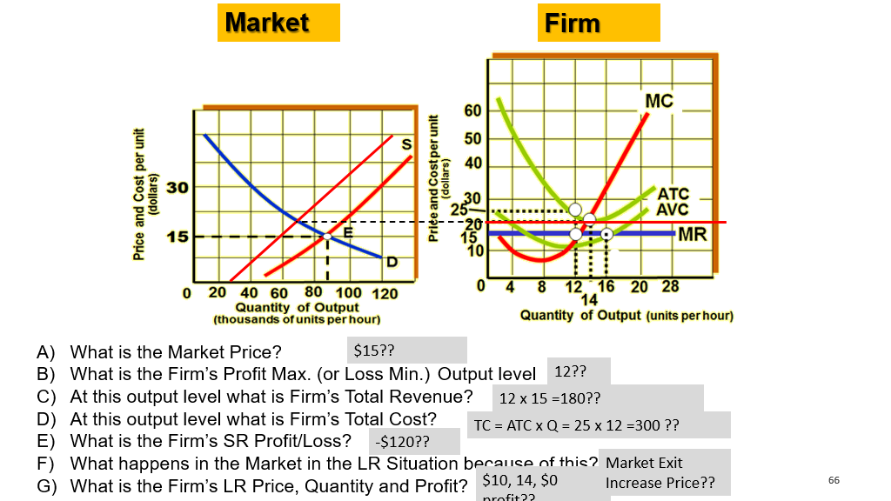

Notes
The four types of competition are on a spectrum of competitiveness. With perfect competition being the most competitive followed by Monopolistic competition, then Oligopoly and at the last place, as least competitive, is Monopoly.

Perfect competition example: large scale agriculture

Total revenue = market price x quantity of output

Find where the MR=MC curve and that is the profit maximized output level

Average cost X quantity = Average Total cost
Average fixed cost X quantity = Total fixed cost

TR-TC= total profit/loss

Zero profit = Normal profit

The spot where the marginal cost passes market price is the shutoff point, any less and the firm can safely assume they will lose less money by shutting down operations. (short run)

As long as profits are maximized OR losses are minimized, a firm can continue to operate normally (short run only, since long term without profits is BAD)

Allocative efficiency = MB=MC (perfect competition achieves this as D= MB and S = MC. So when S=D MB=MC

Productive Efficiency - Is achieved by using the fewest resources to produce a good or service. In perfectly competitive markets, competitive pressure pushes firms towards productive efficiency. In LR in PC produce at a Quantity with lowest ATC… So P= minimum ATC.

LRAC = Long run average total cost.

