Exam 3 Review S25
Perfect Competition
Which Features are essential for an industry to be Perfectly Competitive?
- Large number of firms and Large number of buyers
- Freedom of Entry and Exit into the market
- Each firm produces an identical product

Because each firm is so small relative to the size of the market a firm in Perfect Competition is a Price taker.

The Graph below shows a firm in the Perfectly Competitive Computer industry.
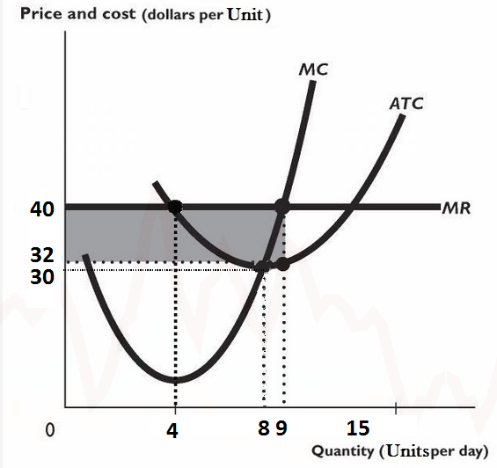
Based on the information in the graph what is the Market Price for a Computer unit? ___$40____
What would be the firm's profit maximizing level of Output? _____9_____
At this profit maximizing level of Output the firm's Total Revenues are? _____$360______
At this profit maximizing level of Output the firm's Total Costs are? ______$288_______
So the firm makes how much profit? ______$72____________

In the Long Run, a Perfectly Competitive firm earns_______Normal_______ Profit
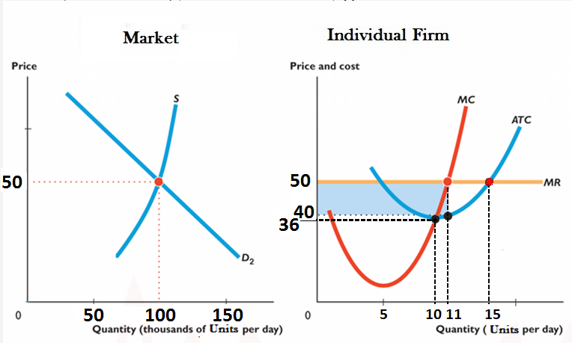Question
The graph above, shows a typical Individual firm in Perfect Competition in the Computer Component industry, and the Component Market. Use it for the next 3 questions.
What is the Market price? _____50___________
What is the profit maximizing Output level for the individual firm? _____11________
What is the equilibrium Market Quantity (Market Quantities are in thousands)? ______100______
How much Economic profit is the typical firm making in the Short-Run?___$110_____
What will this cause to happen in the Market in the Long-Run?______Entry of new firms________
As a result of the Market change you identified above, we would expect..........
In the Long Run, Perfectly Competitive firms produce at the Output level that has the minimum______ATC______
Here that means the LR Price is____$36______
As a result of your answer to the Previous question we know that firms in Perfect Competition in the Long Run achieve_______Productive Efficiency________ (in terms of Allocative and Productive Efficiency)?

Monopoly
What are Barriers to Entry?
What can be a Barrier to Entry?
- Economies of scale
- Legal Barriers
- Ownership of a vital resource

The Table Below gives the Price and Quantity Demanded, Marginal Revenue, Average Total Costs, and Marginal Costs for a Monopoly in a small Texas town. Use it for the
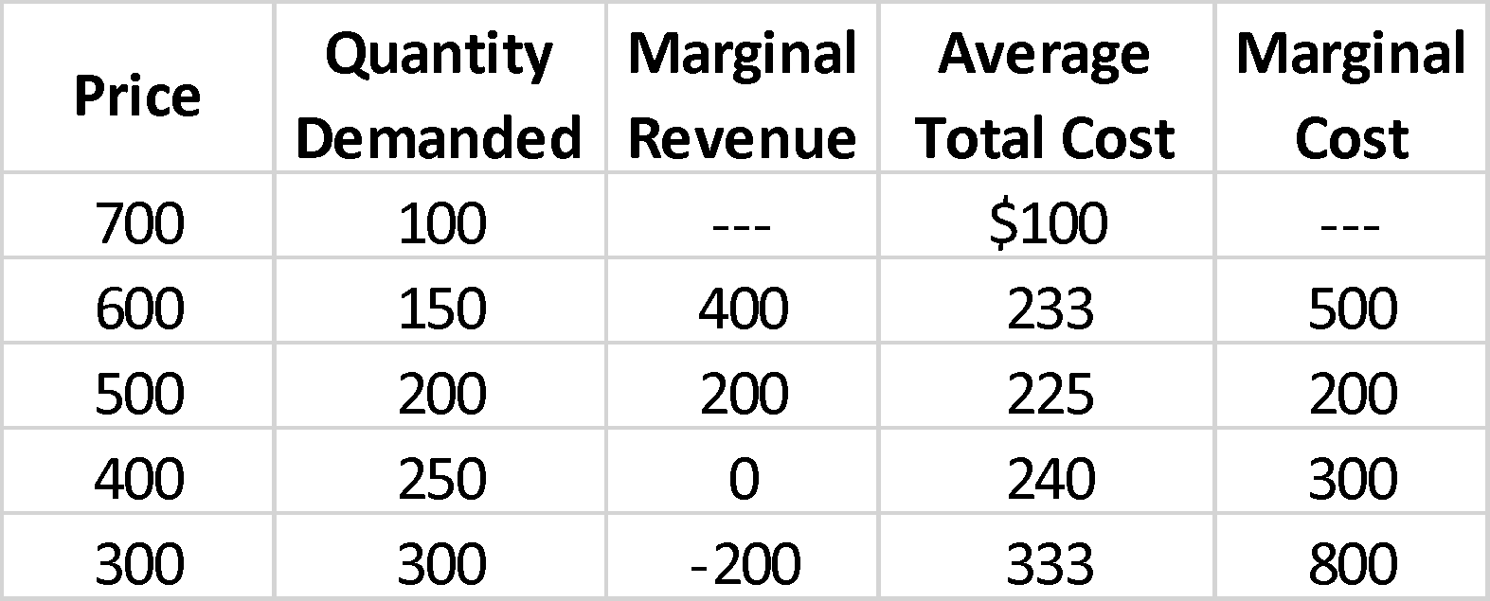
What is the Monopoly’s Profit maximizing Quantity?
200
At this Monopoly’s Profit Maximizing Quantity how much Total Revenue do they make?
$100,000

At this Monopoly’s Profit Maximizing Quantity what are their Total Costs?
$45,000
At this Monopoly’s Profit Maximizing Quantity how much Profit do they make?
$55,000

The Graph below represents the Demand, Marginal Revenue, Marginal Cost and Average Total Cost curves for a small Monopoly--a Barber shop in a small town. Use it for the following questions.
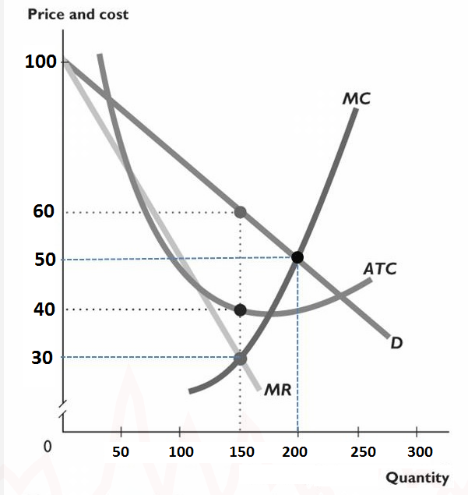
What is the profit maximizing Quantity ____150_________and Price ___________$60___________for this Monopoly?
Based on the Profit Maximizing Quantity and Price you identified above, and the information in the graph, at this Quantity/Price combination the firm's Total Revenue (TR) is ___$9000_________
Based on the Profit Maximizing Quantity and Price you identified above, and the information in the graph, at this Quantity/Price combination the firm's Total Cost (TC) is _____$6000_______]. Whole numbers only, no units.
Based on the TR and TC figures you calculated above, the Monopolist's profit here is _______$3000___________
What will happen to the Monopoly Profits in the LR? Why?
They will persist, due to the extreme barriers to entry
The graph below gives the Demand, Marginal Revenue and Marginal Cost curves (per game) for a Monopoly in Dallas. Use it for the following questions.
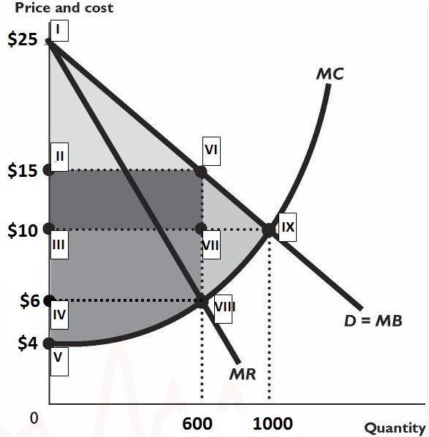
What would be the Profit Maximizing Quantity_______600________ and Price _______$15_________for the Monopoly to sell at?
What would be the Profit Maximizing Quantity ______600________ and Price____________6___________ if instead of a Monopoly, this Nacho market was Perfectly Competitive?
Based on the graph above what area represents the Deadweight loss to society from having a Monopoly in this market, and what is the $ value of this loss_______$1800
In the Long Run Monopoly profits __Persist (if barriers stay in place)______

Compare a Monopoly (Single-price--non-price discriminating) in comparison to Perfect Competition.
Price? Higher in monopolies
Quantity? Lower in monopolies
Cost Minimize? Yes, both are focused on producing where MR=MC
LR Profit? Positive in monopolies, zero in perfect competition
Deadweight Loss? Monopolies create deadweight loss, there is none in PC

Monopolies in terms of Price are _______price makers______ but are still limited by ______demand_______

To be able to Price Discriminate, a firm must be
- be able to segment market.
- sell a product that can’t be resold.
- be a price maker

- If a Monopoly is able to Price Discriminate then__It captures more consumer surplus as profit_______

- If a Monopoly is able to Perfectly Price Discriminate then this means____they are able to charge the maximum a buyer is willing to pay__________and so there will be how much deadweight loss? _____Zero________

Monopolistic Competition
Monopolistic Competition is defined by:
- Large Number of Firms
- Differentiated Products
- Free Entry and Exit

The figure below illustrates a firm's demand and Marginal Revenue curves and its Cost curves. Use the figure below for the following questions.
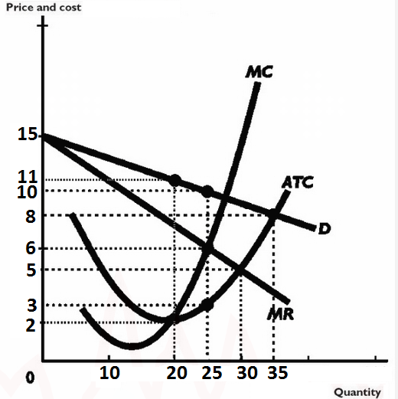

What is the profit maximizing Quantity _______6______and Price ____________$25__________for this firm?
Based on the Profit Maximizing Quantity and Price you identified above, and the information in the graph, at this Quantity/Price combination the firm's Total Revenue (TR) is __$150__________
Based on the Profit Maximizing Quantity and Price you identified above, and the information in the graph, at this Quantity/Price combination the firm's Total Cost (TC) is _______$75_____].
Based on the TR and TC figures you calculated above, the firm's profit here is _______$75___________
As a result of the Profits that Max's earns in the Short-Run, in the Long-Run we would expect_________Entry of new firms, demand shifts left until zero profit is made________

Use the figure below for the next 4 questions.
The figure below shows..
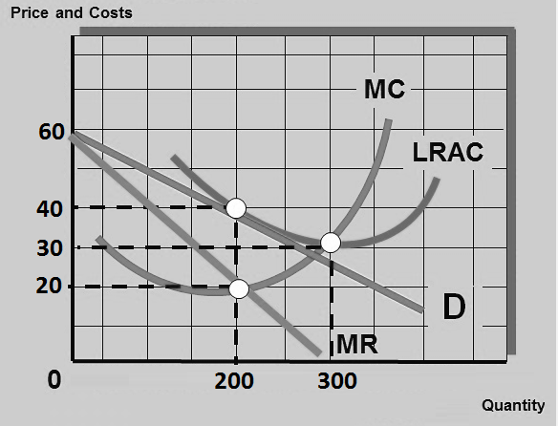
The figure above shows what Market Structure? In the SR/LR? Monopolistic competition?
The Equilibrium Price and Quantity for the situation identified in the question above are:
Price ____$40___and Quantity ______200_______
Based on the Profit Maximizing Quantity and Price you identified above, and the information in the graph, at this Quantity/Price combination the firm's Total Revenue (TR) is ______$8000______
Based on the Profit Maximizing Quantity and Price you identified above, and the information in the graph, at this Quantity/Price combination the firm's Total Cost (TC) is ______$4000______].
The Firm in the Graph above at its Profit maximizing level of Output is earning how many $ ____$4000________of Economic Profit
The firm in the above figure produces at a quantity that is ___100_____ units away from being productively efficient (Excess Capacity)

In Monopolistic Competition, the entry of new firms_________Shifts demand to the left, and reduces profit until zero profit is made__________
The firms in Monopolistic Competition are what in terms of Productive Efficiency and Allocatively Efficiency? …….. But ___Neither productively nor allocatively efficient, but achieve a greater amount of product variety_____________________

How do we represent the impact of Successful Advertising in Monopolistic Competition?
Demand shifts right and up, short run profits increase, demand becomes more inelastic.

