ECO 2302 Principles of Micro Exam 2 Review -- Full

Market Efficiency and Government Policy
Consumer Surplus is?
Producer Surplus is?
What is Total Economic Surplus – where is it Maximized?

In the figure below, the market is at its equilibrium.
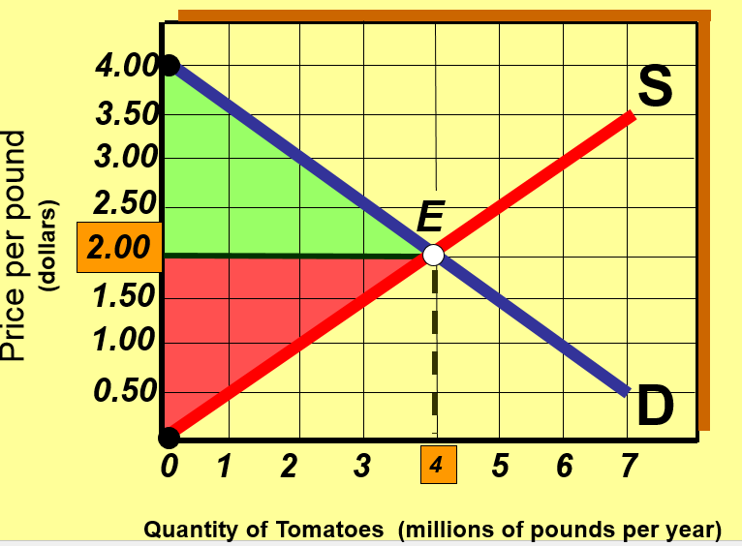
What Area is Consumer Surplus?
What Area is Producer Surplus?
If the Quantity is restricted by the Government to 3 million—what is the $ value of Deadweight Loss?

When the quantity of an output produced in a Market is not equal to the competitive equilibrium quantity what does this cause?
Be able to identify on a Market graph if deadweight loss is present – if so where do we illustrate it? What is its $ value?

Example:
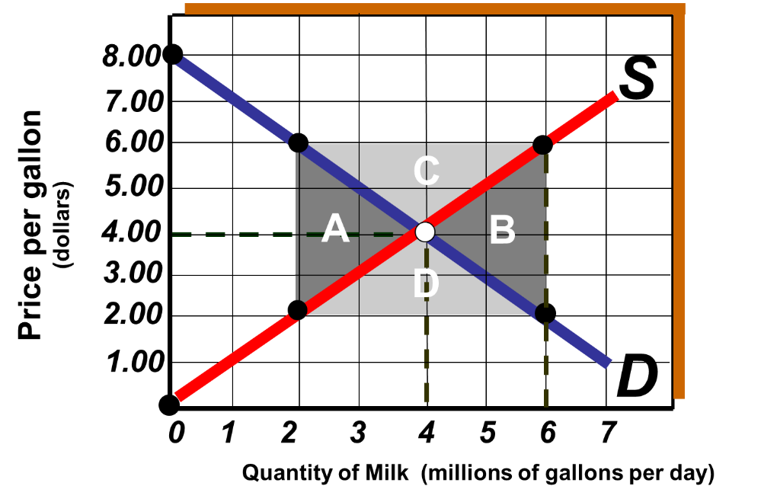
If the above graph represents the US Market for milk—what is the efficient quantity of Milk?
If the government through legislations forces the Milk producers of the US to produce 6 million gallons per day—is this overproduction or underproduction compared to the efficient level—does this cause a Deadweight loss—if so what letter (A, B , C or D) represents this?

What is Allocative efficiency—where does it occur in a Market?
What is Productive Efficiency—when does it occur in Markets?

What are Price Floors—who are the Government trying to help with them?
- What are Examples of them?
What are Price Ceilings—who are the Government trying to help with them?
- What are Examples of them?

The figure below shows the Labor market in a small US city. Use it for the next 3 Questions. LS is the Labor Supply curve, LD is the Labor Demand curve.
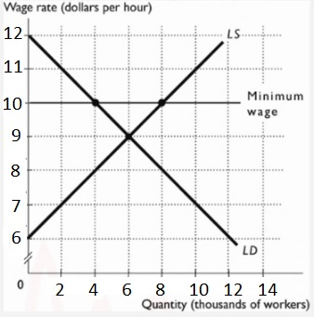
Without any government intervention the Labor market equilibrium would be.....
The figure above shows the Labor market in a region. If a Minimum Wage of $10 an hour is imposed, then there will be....

The figure below shows the market for 2 bedroom apartments in Stephenville
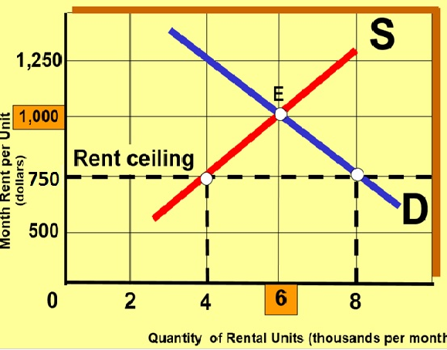
What is the original Market Equilibrium Price and Quantity?
What will happen if a rent ceiling of $750 a month is imposed?
Will this cause a Deadweight loss?

Elasticity (note you will be given formulas shown in the separate sheet):

What are we measuring when we calculate Price Elasticity of Demand and Supply?
If you are given the Percentage change in Quantity and Percentage change in Price be able to Calculate and Interpret the Price Elasticity of Demand and Supply

Be able to Calculate Price Elasticity of Demand from formula and interpret it.
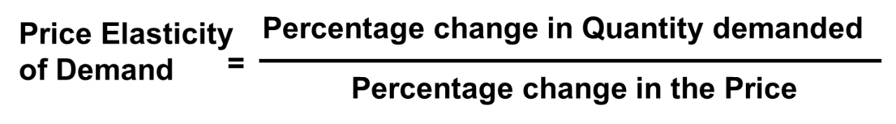
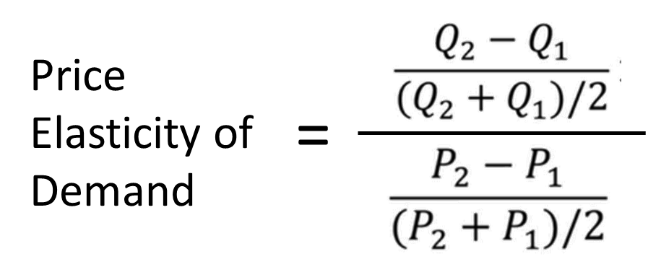
Signs Not important
For Price Elasticity of Demand:
  - What do call Elasticity > 1, Elasticity =1, Elasticity <1?
  - What do these values mean?
How do Factors such as Availability of Substitutes, Proportion of Income spent and Time period effect Price Elasticity of Demand?
When Demand is Inelastic what happens to Total Revenue when Price Changes?
When Demand is Elastic what happens to Total Revenue when Price Changes?

Example:
The Quantity demanded of Cosmopolitan magazines decreases from 1,250,000 to 750,000 copies each month, when the magazine's price increases from $4 to $6. Using the midpoint method, the Price Elasticity of Demand equals
%Change in Q =
%Change in P =
Elasticity =

Understand Income Elasticity of Demand ,how to calculate it using Midpoint Formula and interpret it
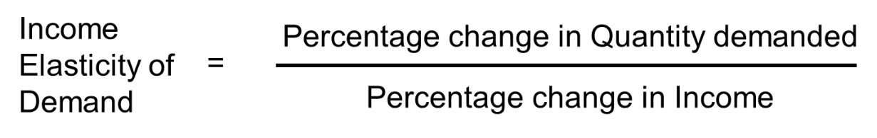
Signs Important –you will be given the Percentages here.
What do we call it and what does it mean when: Income Elasticity>0?
What do we call it and what does it mean when: Income Elasticity<0?

Example – if Texas Income +20% -- Demand for Kia automobiles Falls by 5% -- What is Income Elasticity of Demand of Kias here? ___________

Understand Cross Elasticity of Demand and how to calculate and interpret it.
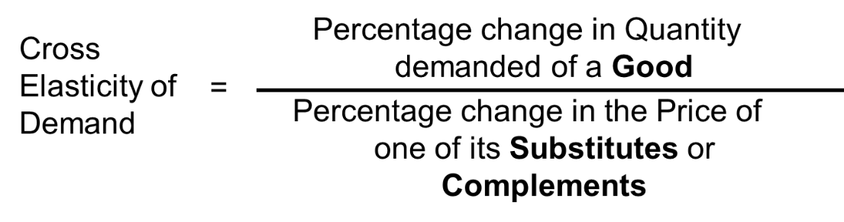
Signs Important –you will be given the Percentages here.
Complements Value?
Substitutes Value?

Examples:
IN Texas – P Ranch Dressing +20% >> Qd of Pizza falls by 40% What is Cross Elasticity of Demand? ___________

IN London P of Fish n Chips +10% >> Qd of Pizza rises by +20% What is Cross Elasticity of Demand? ___________

Be able to Calculate Price Elasticity of Supply from midpoint formula and interpret it.
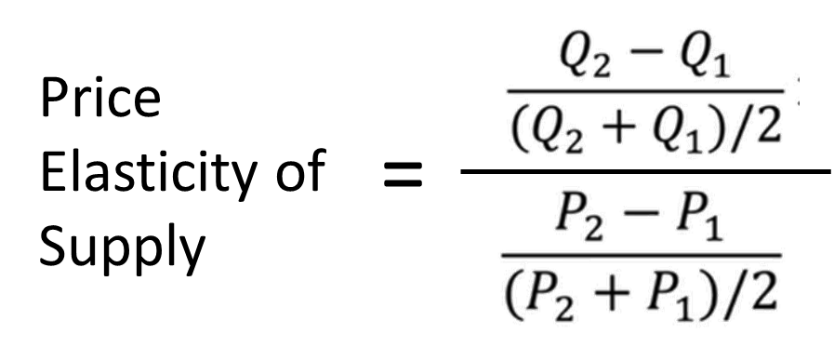
Signs Not important
For Price Elasticity of Supply:
  - What do call Elasticity > 1, Elasticity =1, Elasticity <1?
  - What do these values mean?
How does Time Period effect Price Elasticity of Supply?

Example:
Suppose Q supplied of Pizza rises from 20 to 60 an hour >> when Price of Pizza rose from $8 to $12.
To calculate Price Elasticity of Supply using the Midpoints formula:
- %Change in Q =
- %Change in P =
- So Elasticity of SUPPLY =
- How would you classify this? What does this mean?

See the Elasticity Review—Not for Credit Questions, and Answers in the Canvas Elasticity Module for more examples on how to work these Elasticity Problems

Production and Costs

What is main goal of firm --- to Maximize Profits
Economic Profit = Total Revenue – Total Economics Costs
Or Economic profit = Total Revenue - Explicit costs - Implicit costs
Be able to identify and describe what are Explicit Costs and What are Implicit Costs

For the Business example below, where the firm owner provides some of their own Labor, uses a building they could rent out to others, and invests their own savings. Figure:
Item | $ Value
Total Revenue | 500,000
Materials | 50,000
Wages | 400,000
Other Costs | 20,000
Foregone Salary | 50,000
Foregone Rent | 10,000
Foregone Interest | 5,000
What are Total Explicit Costs?
What are Total Implicit Costs?
What is Economic Profit?
Should the firm stay in Business?

Short Run--time frame when quantities of some Resources are Fixed (only Labor Variable)
Long Run--time frame when Quantities of all Resources can be changed

Be able to calculate Marginal and Average Productivity
- Marginal Product--change in Total product from one-unit increase in Quantity of Labor employed
- Average Product (Productivity) = Total product ÷ Quantity of Labor

The table gives the data for Bob's MP3 Players (a small MP3 player making firm).

Use the table in the table below to calculate the Average Productivity (AP) the Marginal Productivity (MP) of Various amounts of Labor, in terms of MP3 Units per hour.
Labor | Output | MP | AP
Workers per hour | Units per hour | Units per hour | Units per hour
0 | 0 | ------
1 | 50
2 | 90
3 | 120
4 | 130
5 | 130

Short Run Costs (see either EG1 or EG2 below):
- Total Cost (TC) is sum of Total Fixed Cost and Total Variable Cost (EG1)
- Total Fixed cost—stays same no matter the Quantity (EG1)
- Total Variable cost—increases with output -- values will be given in number examples (EG1)
- Marginal Cost (MC) --change in Total Cost from a one-unit increase in Output (EG2)
- Average Total Cost (ATC) = Total Cost ÷ units of Output (EG2)

EG1: All Labor and Costs are per hour. Fixed Costs of $25 an hour
Be able to calculate Total Cost

Output | Total Fixed Cost | Total Variable Cost | Total Cost
gal per hour | $ per gallon | $ per gallon | $ per gallon
0 |  | 0
1 |  | 10
2 |  | 15
3 |  | 20
4 |  | 30
5 |  | 50

EG2:
Given Output and Total Cost be able to Calculate Marginal and Average Total Cost—What Output level does the firm Cost-Minimize at?

Remember firm Cost Minimizes at Output level where ATC lowest
On graph this is where the MC cuts the ATC

For generic Cost curves below—be able to identify Marginal Cost, Average Fixed Cost, Average Variable Cost and Average Total Cost Curves
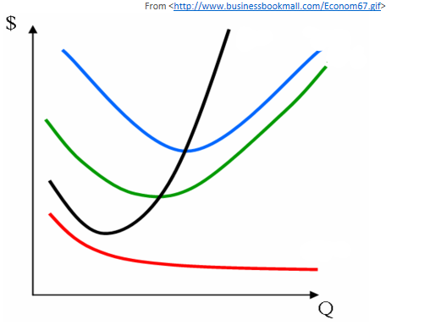

Long Run Costs
- Long-Run Average Cost (LRAC) curve shows lowest Average Cost at which it is possible to produce each output level at (when can change Capital amounts).
- Economies of Scale—Increase Output and LRAC goes down (Output 0 to 9 in graph below)
- Diseconomies of Scale—Increase Output and LRAC goes up (Output above 12 in graph)
- Constant Returns to Scale—Increase Output LRAC stays roughly the same (Output 9—12 in graph)

