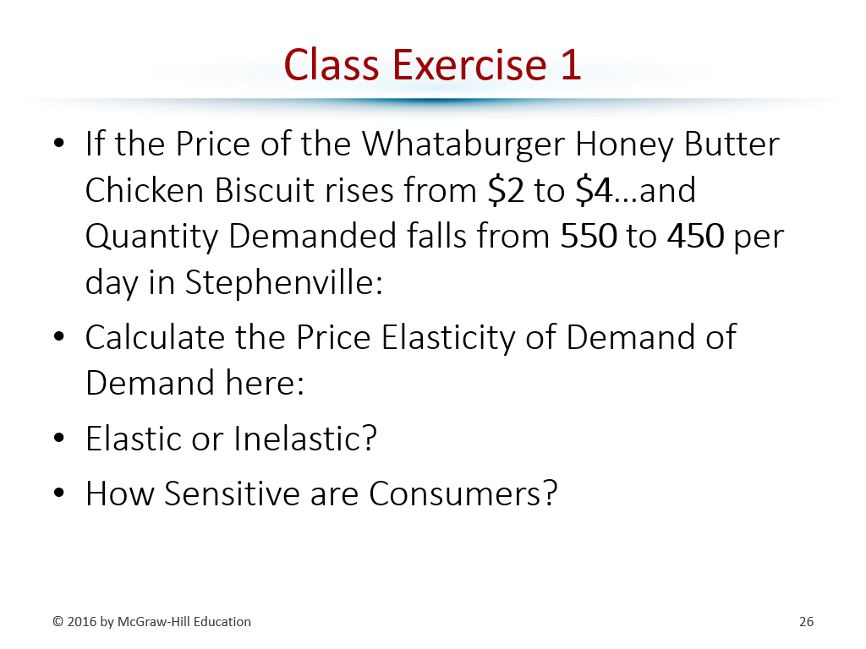
The following 3 exercises are from September 30th
(relevant keys can be found on the page following a class days exercise)

Class Exercise #2
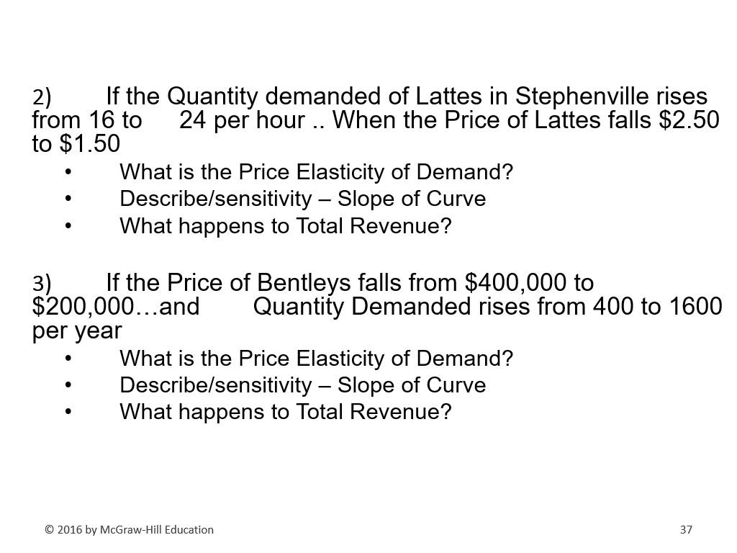

Key provided on the next page.
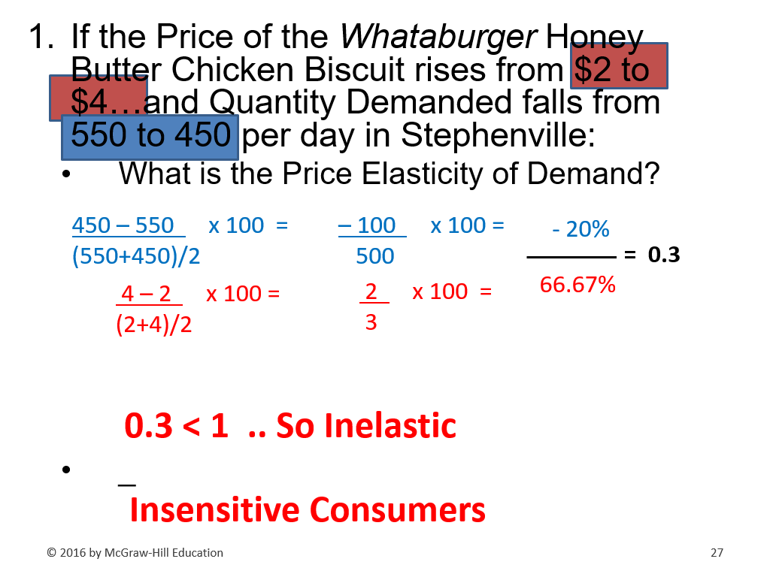

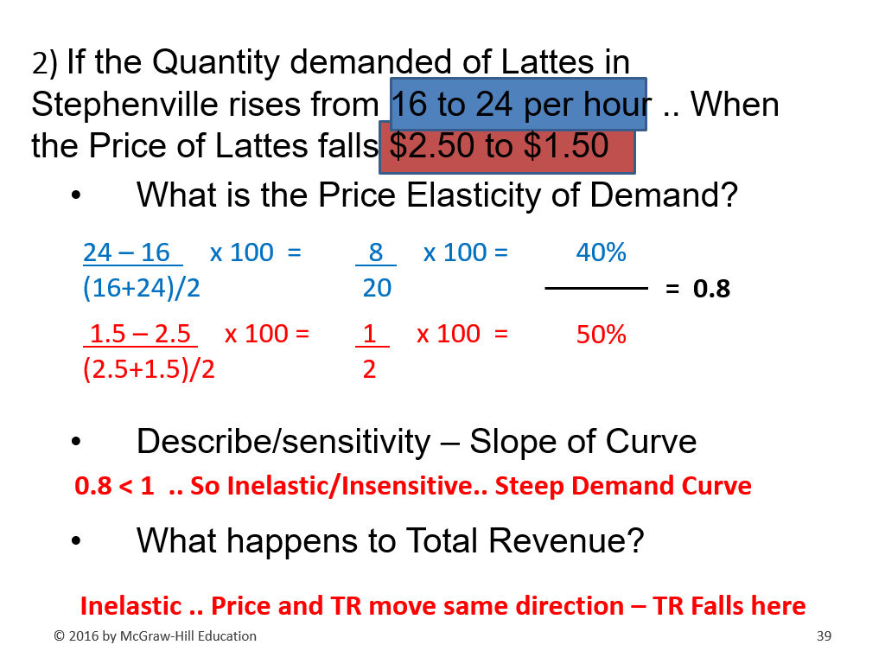

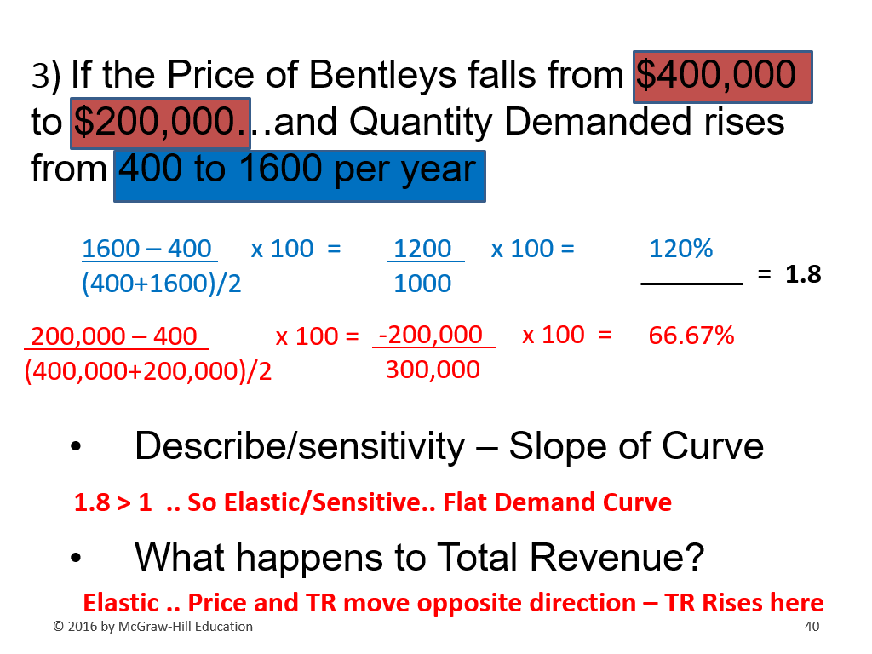

Class Exercises on 10/02/25
Keys are provided on the following page.

2.) Quantity Demanded of Gatorade falls by 100% when Price of
Powerade falls by 40%. Cross Elasticity of Gatorade? Describe​

​
3.) Quantity supplied of Tomatoes increases from 200 to 800
tons/day when Price of rises from $2/lb to $4/lb​
Price Elasticity of Supply? Describe​

4) Quantity Demanded of Honda cars rises from 2,000 to 2,400 day
(20%)when Texas Income Increases from $4,000 to $5,000 (25%)
month​

