ECON 2302 EXAM 1 REVIEW

MODULE 1

What is analyzed in Macroeconomics/Microeconomics?
Micro:

Macro:

What is Scarcity?
Scarcity implies that:

Opportunity Cost is defined as: _________________

Which of following are classified in Economics as Resources?

Land
Money
Labor
Capital
Entrepreneurial Ability

In Economics we assume that Decision Making involves what 3 things.
- __Self-interest__________
- __Marginal Decision_________
- ___Optimization________

Deb is hungry after shopping in the mall, and enjoys Cookies, and has cash so she can afford to buy up to 8 big Cookies. The table below describes the Marginal Benefit Deb gets for consuming each additional Cookies. Use this for the next 2 Questions.
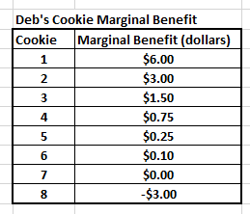

If the Price of one of these Cookies was $3, how many would Deb buy if she was rational?
1
2
3
4

If the price of Cookies fell to $0.75 each (it is the end of the day), how many Cookies would Deb now buy if she was rational?
2
3
4
5
6

To Optimize through Marginal analysis for an activity, in terms of Marginal Benefit (MB) and Marginal Cost (MC), it is always best to:

MODULE 2

The figure below shows the Production Possibilities Frontier for a country. Use it for the following 3 questions.
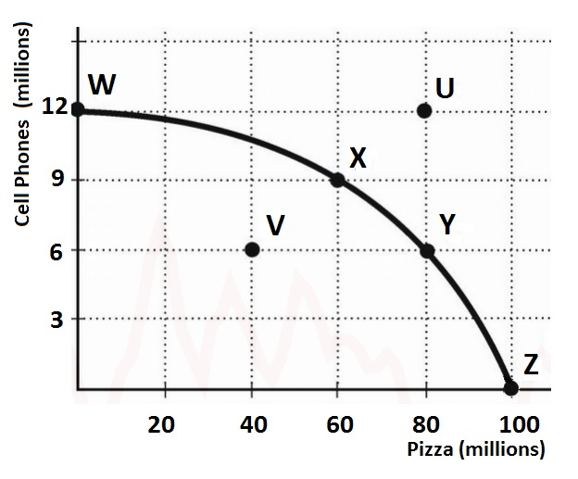

The point or points that are Possible and Production Efficient are:
Which point or points is Production Inefficient?
Which point in the figure above is an IMPOSSIBLE combination given the current level of resources and technology

Comparative Advantage in the setting of individuals or international trade, is when a.......

Let the following table represent the production possibilities for China and the U.S.A. for TVs and Jets. The table represents the endpoints of their respective (straight line) production possibilities curves—that is if China devoted all of its resources to producing TVs it could make 400 units (and no units of Jets), or alternatively if it devoted all of its resources to producing Jets it could make 200 units of Jets (and no units of TVs). USE for the following 5 Questions.
Assume initially China started off making 200T and 40J, and the USA started off 150T and 50 J
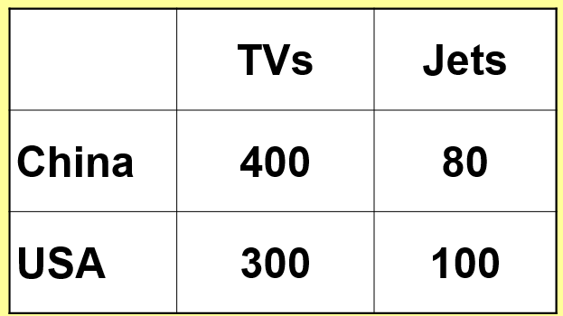

Based on the information in the table above, calculate what are the Opportunity Costs for each country every time they increase their Jet Production by 1 unit?

China _______TVs:1 Jet>>>>U.S.A ______ TVs:1 Jet

Based on your answer to the questions above, does either country have a Comparative Advantage?

_______ has a Comparative Advantage in Jets
_______ has a Comparative Advantage in TVs

Based on the Opportunity costs you calculated in the question above, what might be an acceptable trading ratio of TVs to Jets (that would make both countries better off), that would motivate trade between the two countries following specialization by Comparative Advantage?

___________ TVs: 1 Jet

If both countries completely specialize in the production of the good that they have a Comparative Advantage in, and then the country that has a Comparative advantage in Jet production trades 40 units of Jets at the ratio from the question above what would the trade be, and what would be the final levels as a result (in terms of TVs/Jets)?
Trade
___________ TVs: 40 Jets

Final Levels
China ________ TVs ___________Jets
USA ________ TVs ___________Jets

Based on the initial Production levels (China started off making 200T and 40J, and the USA started off 150T and 50 J)
as the result of the trade in the previous question following Specialization according to Comparative Advantage......

Trade has made Both Countries Better off (they are outside their original PPCs)
Trade has made Both Countries Worse off (they inside their original PPCs)
Trade has made China Better off, and the USA Worse off (both are on their original PPCs)
Trade has made China Worse off, and the USA Better off (both are outside their original PPCs)

Let the following table represent the production possibilities for France and the U.S.A. for Cheese and Movies. The table represents the endpoints of their respective (straight line) production possibilities curves—that is if France devoted all of its resources to producing Cheese it could make 100 units (and no units of Movies), or alternatively if it devoted all of its resources to producing Movies it could make 100 units of Movies (and no units of Cheese). USE for the following 5 Questions
Assume initially France started off making 50 C and 50 M, and the USA started off 150 C and 50 M
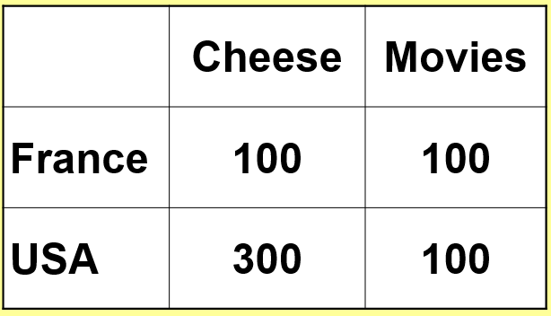

Based on the information in the table above, calculate what are the Opportunity Costs for each country every time they increase their Movie Production by 1 unit?

France ______Cheese:1 Movie>>>>U.S.A _____ Cheese:1 Movie

Based on your answer to the questions above, does either country have a Comparative Advantage?

____has a Comparative Advantage in Movies
_____ has a Comparative Advantage in Cheese

Based on the Opportunity costs you calculated in the question above, what might be an acceptable trading ratio of Cheese to Movies (that would make both countries better off), that would motivate trade between the two countries following specialization by Comparative Advantage?

___________ Cheese:____ Movie

If both countries completely specialize in the production of the good that they have a Comparative Advantage in, and then the country that has a Comparative advantage in Movie production trades 50 units of Movies at the ratio from the question above what would the trade be, and what would be the final levels as a result (in terms of Cheese/Movies)?
Trade
______ Cheese: ________ Movies

Final Levels
France _____ Cheese _________Movies
USA ________ Cheese _________Movies

Based on the initial Production levels (France started off making 50 C and 50 M, and the USA started off 150 C and 50 M)
as the result of the trade in the previous question following Specialization according to Comparative Advantage......

Trade has made Both Countries Better off (they are outside their original PPCs)
Trade has made Both Countries Worse off (they inside their original PPCs)
Trade has made France Better off, and the USA Worse off (both are on their original PPCs)
Trade has made France Worse off, and the USA Better off (both are outside their original PPCs)

MODULE 3

Stated as simply as possible the Law of Demand says that ....

The Income Effect, the Substitution Effect, and Diminishing Marginal Utility are…
The three forces that always bring a Market back to its Equilibrium Price
The three reasons why Supply Curves are Downward Sloping
The three reasons why Demand Curves are Downward Sloping
The only 3 factors that will shift the Whole Demand Curve (cause a Change in Demand)

Which of the answers below that are Nonprice Demand Shifters that will cause a "Change in Demand"

A change in the Price of Substitutes and Complements
Income Changes
Number of Buyers changes
Taste and Preferences changes
Changes in the Price of this good
Changes in the Number of sellers

Looking at the two changes in the graph below (1 and 2)--the whole curve shifting in change (1), moving from point A to point B on curve D01 in change (B)--which of the statements below describe these changes?

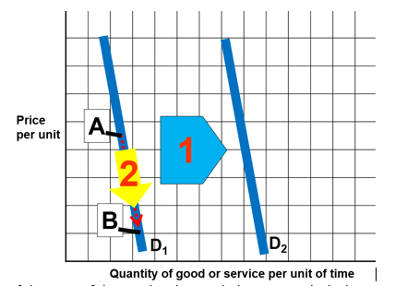

(1) is a Decrease in Demand , (2) is a Decrease in Quantity Demanded
(1) is an Increase in Demand , (2) is an Increase in Quantity Demanded
(1) is a Decrease in Quantity Demanded , (2) is an Increase in Demand
(1) is an Increase in Quantity Demanded , (2) is a Decrease in Demand

The Law of Supply states that, other things remaining the same,

The Price at which Quantity demanded equals Quantity supplied is called .....

Use the graph below to fill in the blanks. In the Sneaker Market below the Equilibrium Price is $___________ and the Equilibrium Quantity is ________ per year.
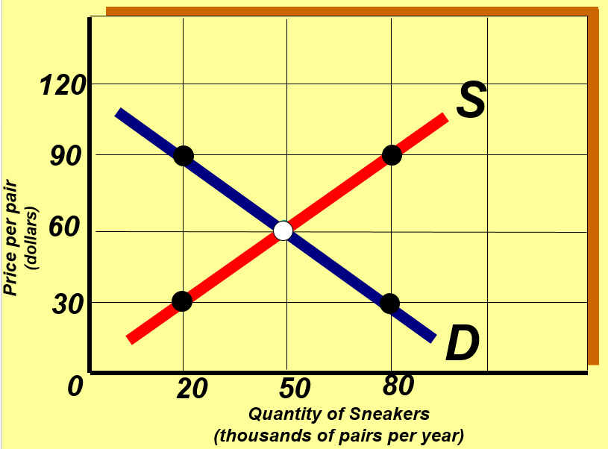

In the market above a price of $30 per results in:

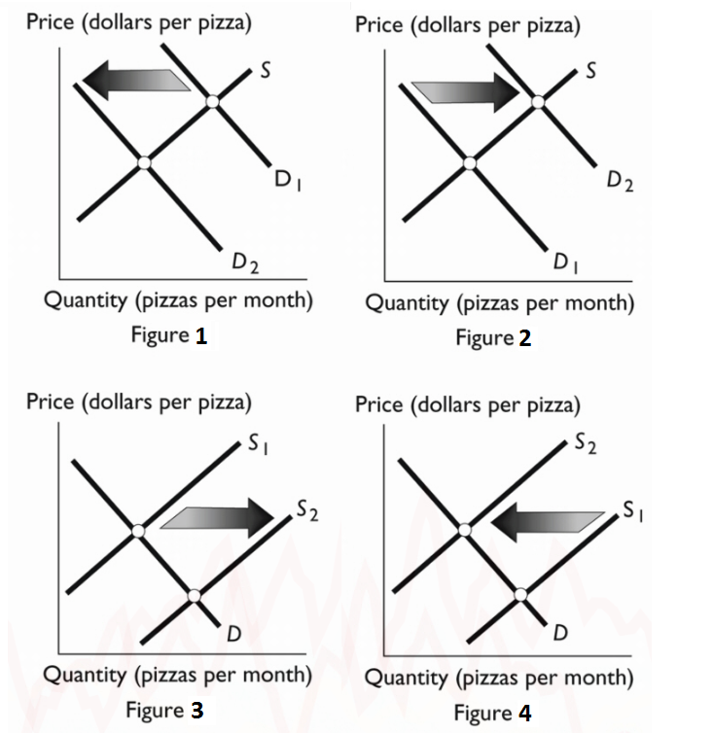

The Surgeon General announces that Pizza helps you live longer. Which figure below shows the impact of this?

As a Result of the Graph shift you identified in the question above we would then have....

The Price __ and Quantity ___

Based on the Pizza market graphs above, which figure shows an Increase in Supply?

As a result of the curve shift you identified in the question above Question to represent an Increase in Supply in the Pizza Market, we would expect:
The Price ___ and Quantity __

Ranch dressing(a complement to Pizza) prices rise
P ____ Q ____

