Exam 3 Review S25
Perfect Competition
Which Features are essential for an industry to be Perfectly Competitive?
- Large number of firms and Large number of buyers
- Freedom of Entry and Exit into the market
- Each firm produces an identical product

Because each firm is so small relative to the size of the market a firm in Perfect Competition is a ___________

The Graph below shows a firm in the Perfectly Competitive Computer industry.
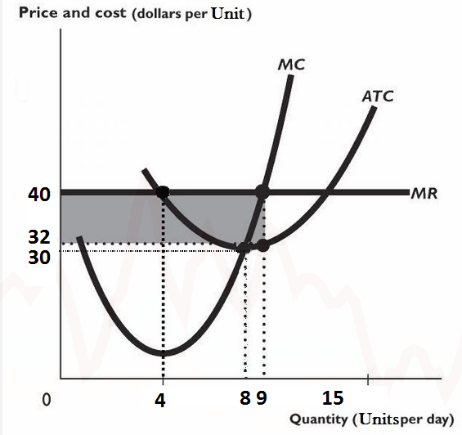
Based on the information in the graph what is the Market Price for a Computer unit? ________
What would be the firm's profit maximizing level of Output? ___________
At this profit maximizing level of Output the firm's Total Revenues are? _____________
At this profit maximizing level of Output the firm's Total Costs are? _____________
So the firm makes how much profit? __________________

In the Long Run, a Perfectly Competitive firm earns______________ Profit
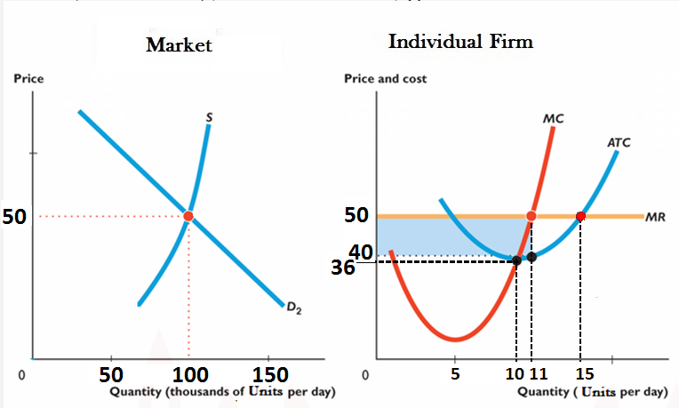Question
The graph above, shows a typical Individual firm in Perfect Competition in the Computer Component industry, and the Component Market. Use it for the next 3 questions.
What is the Market price? ________________
What is the profit maximizing Output level for the individual firm? _____________
What is the equilibrium Market Quantity (Market Quantities are in thousands)? ____________
How much Economic profit is the typical firm making in the Short-Run?________
What will this cause to happen in the Market in the Long-Run?______________
As a result of the Market change you identified above, we would expect..........
In the Long Run, Perfectly Competitive firms produce at the Output level that has the minimum____________
Here that means the LR Price is__________
As a result of your answer to the Previous question we know that firms in Perfect Competition in the Long Run achieve_______________ (in terms of Allocative and Productive Efficiency)?

Monopoly
What are Barriers to Entry?
What can be a Barrier to Entry?
- ?
- ?
- ?

The Table Below gives the Price and Quantity Demanded, Marginal Revenue, Average Total Costs, and Marginal Costs for a Monopoly in a small Texas town. Use it for the
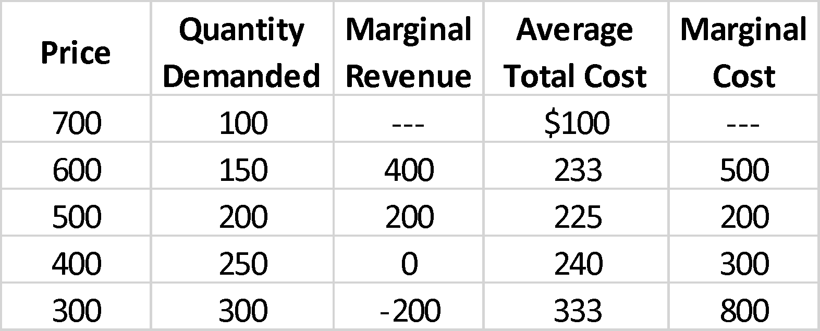
What is the Monopoly’s Profit maximizing Quantity?

At this Monopoly’s Profit Maximizing Quantity how much Total Revenue do they make?

At this Monopoly’s Profit Maximizing Quantity what are their Total Costs?

At this Monopoly’s Profit Maximizing Quantity how much Profit do they make?

The Graph below represents the Demand, Marginal Revenue, Marginal Cost and Average Total Cost curves for a small Monopoly--a Barber shop in a small town. Use it for the following questions.
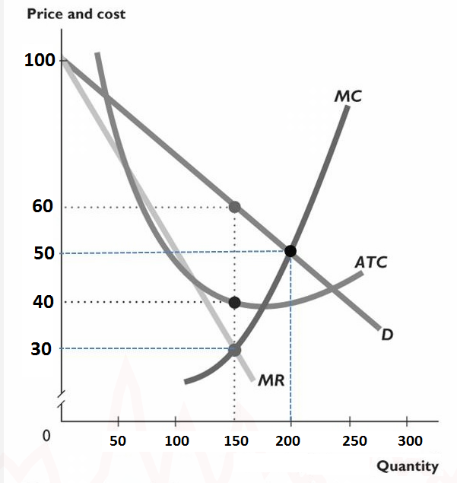
What is the profit maximizing Quantity _____________and Price ______________________for this Monopoly?
Based on the Profit Maximizing Quantity and Price you identified above, and the information in the graph, at this Quantity/Price combination the firm's Total Revenue (TR) is ____________
Based on the Profit Maximizing Quantity and Price you identified above, and the information in the graph, at this Quantity/Price combination the firm's Total Cost (TC) is ____________]. Whole numbers only, no units.
Based on the TR and TC figures you calculated above, the Monopolist's profit here is __________________
What will happen to the Monopoly Profits in the LR? Why?

The graph below gives the Demand, Marginal Revenue and Marginal Cost curves (per game) for a Monopoly in Dallas. Use it for the following questions.
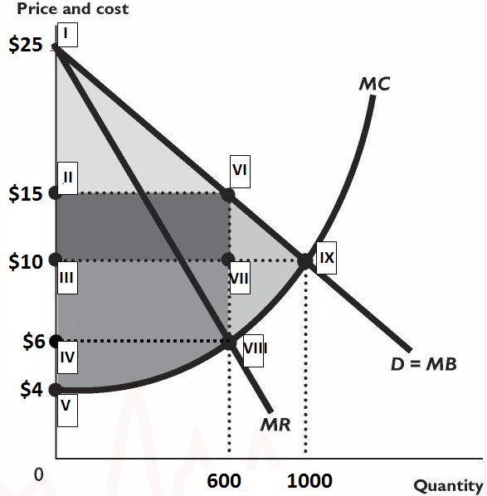
What would be the Profit Maximizing Quantity_______________ and Price ________________for the Monopoly to sell at?
What would be the Profit Maximizing Quantity ______________ and Price_______________________ if instead of a Monopoly, this Nacho market was Perfectly Competitive?
Based on the graph above what area represents the Deadweight loss to society from having a Monopoly in this market, and what is the $ value of this loss_____________
In the Long Run Monopoly profits ________

Compare a Monopoly (Single-price--non-price discriminating) in comparison to Perfect Competition.
Price?
Quantity?
Cost Minimize?
LR Profit?
Deadweight Loss?

Monopolies in terms of Price are _____________ but are still limited by _____________

To be able to Price Discriminate, a firm must be
- be able to segment market.
- sell a product that can’t be resold.
- be a price maker

- If a Monopoly is able to Price Discriminate then______________

- If a Monopoly is able to Perfectly Price Discriminate then this means______________and so there will be how much deadweight loss? _____________

Monopolistic Competition
Monopolistic Competition is defined by:
- Large Number of Firms
- Differentiated Products
- Free Entry and Exit

The figure below illustrates a firm's demand and Marginal Revenue curves and its Cost curves. Use the figure below for the following questions.
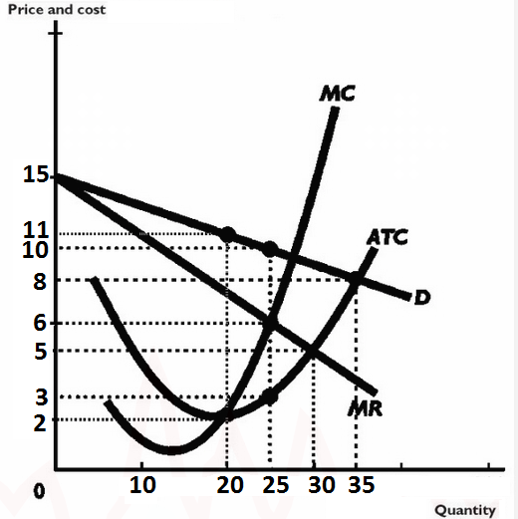

What is the profit maximizing Quantity _____________and Price ______________________for this firm?
Based on the Profit Maximizing Quantity and Price you identified above, and the information in the graph, at this Quantity/Price combination the firm's Total Revenue (TR) is ____________
Based on the Profit Maximizing Quantity and Price you identified above, and the information in the graph, at this Quantity/Price combination the firm's Total Cost (TC) is ____________].
Based on the TR and TC figures you calculated above, the firm's profit here is __________________
As a result of the Profits that Max's earns in the Short-Run, in the Long-Run we would expect_________________

Use the figure below for the next 4 questions.
The figure below shows..
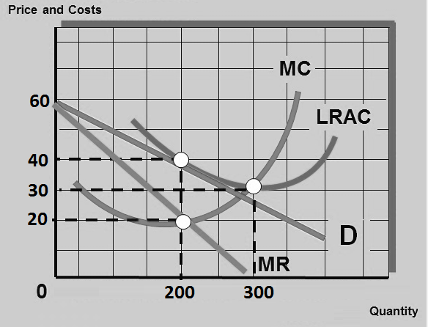
The figure above shows what Market Structure? In the SR/LR?
The Equilibrium Price and Quantity for the situation identified in the question above are:
Price _______and Quantity _____________
Based on the Profit Maximizing Quantity and Price you identified above, and the information in the graph, at this Quantity/Price combination the firm's Total Revenue (TR) is ____________
Based on the Profit Maximizing Quantity and Price you identified above, and the information in the graph, at this Quantity/Price combination the firm's Total Cost (TC) is ____________].
The Firm in the Graph above at its Profit maximizing level of Output is earning how many $ ____________of Economic Profit
The firm in the above figure produces at a quantity that is ________ units away from being productively efficient (Excess Capacity)

In Monopolistic Competition, the entry of new firms___________________
The firms in Monopolistic Competition are what in terms of Productive Efficiency and Allocatively Efficiency? …….. But ________________________

How do we represent the impact of Successful Advertising in Monopolistic Competition?

