Profit maximization-

Explicit Costs- Monetary payments made by individuals, firms, and governments for the use of resources owned by others.

Implicit Costs- The opportunity costs of using owned resources.​ (forgone?)

Opportunity Costs- The value of the next-best foregone alternative.

Short Run- The time period in which at least one input of production is fixed but other inputs can be changed.

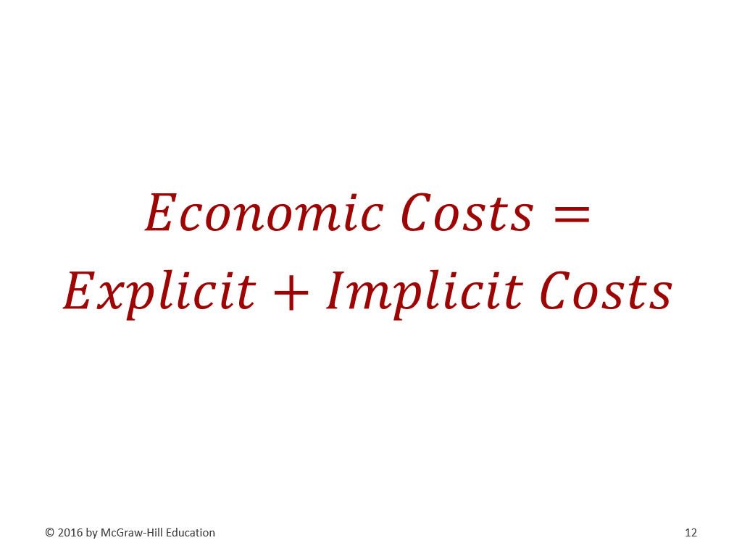
Total Product- The total amount of output produced with a given amount of resources.

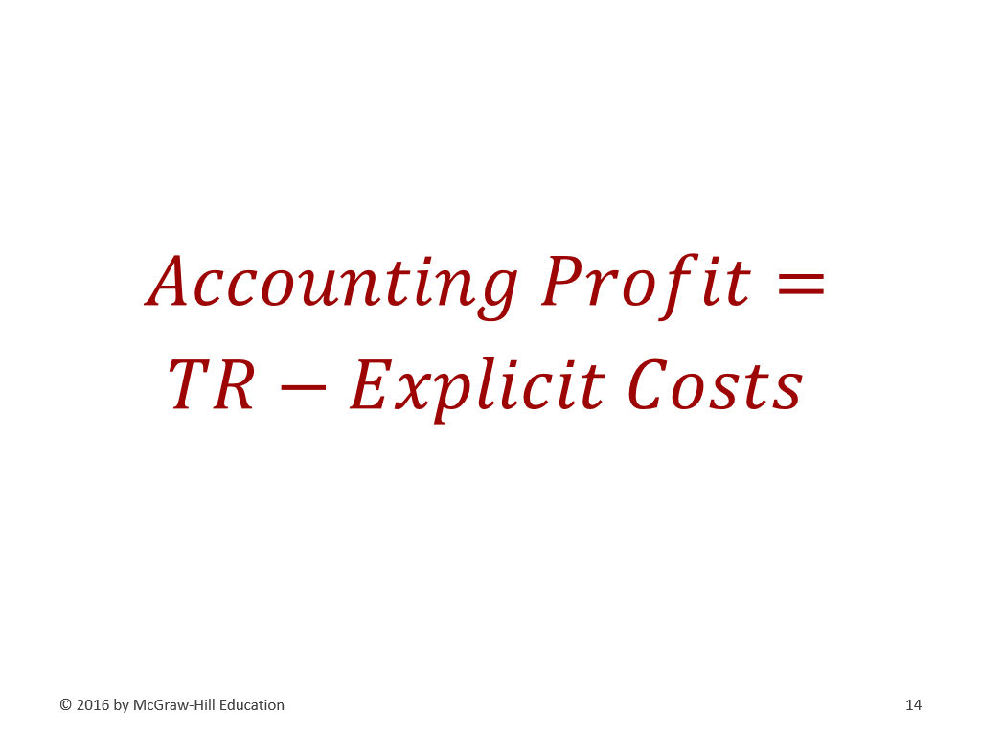

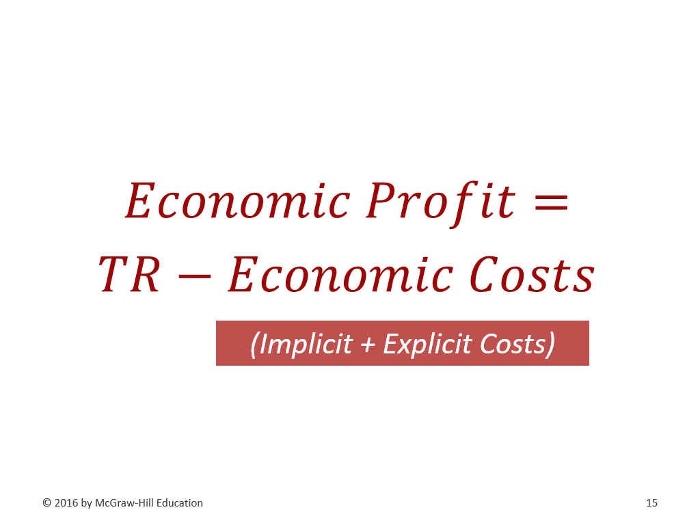

Why does marginal productivity get smaller?

Increasing Marginal Returns- A characteristic of production whereby the MP of the next unit of a variable resource utilized is greater than that of the previous variable resource.

Diminishing Marginal Returns- A characteristic of production whereby the marginal product of the next unit of a variable resource utilized is less than that of the previous variable resource.

Fixed Costs- Costs that do not change with the amount of output produced.

Variable Costs- Costs that change with the amount of output produced, increasing as production increases and decreasing as production decreases.

Total Costs- The sum of fixed and variable costs of production.

Average Fixed Costs- Total fixed cost divided by the amount of output produced.

Average variable costs- Total variable cost divided by the amount of output produced.

Average total costs- Total cost divided by the amount of output produced.

Marginal Costs- The additional cost associated with 1 more unit of an activity.

Long run- The time period in which all inputs of production can be changed.

Long-Run Average Total Cost Curve- A curve showing the lowest average total cost possible for any given level of output when all inputs of production are variable.

Economies of Scale- A condition in which the long-run average total cost of production decreases as production increases.

Diseconomies of Scale- A condition in which the long-run average total cost of production increases as production increases.

Constant returns to scale- A condition in which the long-run average total cost of production remains constant as production increases.

Bonus Formulas:

